Northern Cape Basic Concepts Advocacy Project – Phase 2 (2020-2021)

Exploratory Visit to Frances Baard, 2-3 October 2019

Purpose of the visit:
The visit was arranged to the Frances Baard District (FB), where the project will be initiated next year. The project leader, accompanied by three provincial and three district officials from the NCDOE, visited the district to do preparatory - as well as advocacy work ahead of the start of the project.
The main objectives of the visit were to:-
- Meet with the district leadership and local officials
- Plan the project logistics with local and provincial officials
- Hold information meeting with principals, HODs and teachers from the selected schools
- Do site visits to a sample of selected schools
- Meet with prospective project volunteers
(See Appendix 1 for the visit agenda given to the district in preparation for the visit)
Summary of activities:
Nature of Activity | With Whom | Place | Number of Participants
- Information Meeting with a Question & Answer Session | District Director, District ECD Head, GET Coordinator, District and Provincial Officials | Head Office, Northern Cape Department of Education, Kimberley | 8
- Planning Meeting | District and Provincial Officials | Head Office, Northern Cape Department of Education | 5
- Site Visits | 2 Schools & 1 Community Based Site | Florianville, Galashewe, Homestead | 7 teachers  2 principals  3 district officials
- Advocacy Meeting | Teachers, Principals and HODs | Head Office, Northern Cape Department of Education | 80
- Meeting | Volunteers | Head Office, Northern Cape Department of Education | 5
General impressions and outcomes:
- Phase 2 of the project was given strong, unequivocal support from the district leadership. They in fact promised to promote the programme with their district principals at a meeting later this month.
- The leadership of the district explained that they regarded the project as essential as there was a total lack of intervention programmes in the early - and foundation years.
- The district officials (with the exception of one official who was ill), who we have been working with during Phase 1, have remained very positive about the project and the prospect of it being implemented in their district next year.
- The meeting with the district and provincial officials to discuss the project logistics proceeded without difficulty. All issues were comprehensively discussed and a follow-up list of issues has already been sent to the district officials.
- The main topic of discussion at the district logistics meeting was the selection of the project teachers. Even though the schools and teachers have already been selected by the district, it is hoped that the list will be refined to avoid difficulties during project implementation. For example, we identified a teacher on the list who will be moving to teach in Grade 1 next year who is occupying a place that could be taken by another teacher.
- 21 of the 22 schools that had been invited to participate in the project attended an Advocacy Meeting with their principals and HODs. An additional school that had not been invited also attended the session. There were a total of 80 participants at this meeting.
- The Advocacy Meeting proceded well. The participants seemed interested and motivated to be a part of the project next year. The district officials in fact reported that they received calls from other interested schools in the district after the meeting.
- The site visits were particularly helpful for the project leader to gain insight into a small sample of schools that would be part of the project. It is evident that Phase 2 of the project will include a much more diverse range of learners, schools and teachers. In this Phase there are private and non-private Community Based Sites, No Fee schools and Ex-model C schools included in the current list of sites/schools.
- Furthermore, it was evident from our visits that schools would be well - to reasonably well suited to implement the project. The classes were adequately resourced and seemed organized to run a small group intervention programme during the school day. The number of learners per class ranged from 22 to 39 learners. In all the classes visited there were student - or assistant teachers present. We also experienced some problems gaining access at one school and at another we found that the school was closing early because of disruptions to the water supply in the town.
- Two potential volunteers attended the Advocacy Meeting and also agreed to meet with the Project Leader and District Officials. The two women, both ex-teachers, are exceptionally good candidates. They have completed the volunteer application form. We also attempted to recruit additional volunteers at the Advocacy Meeting. The project will require about 4 volunteers.
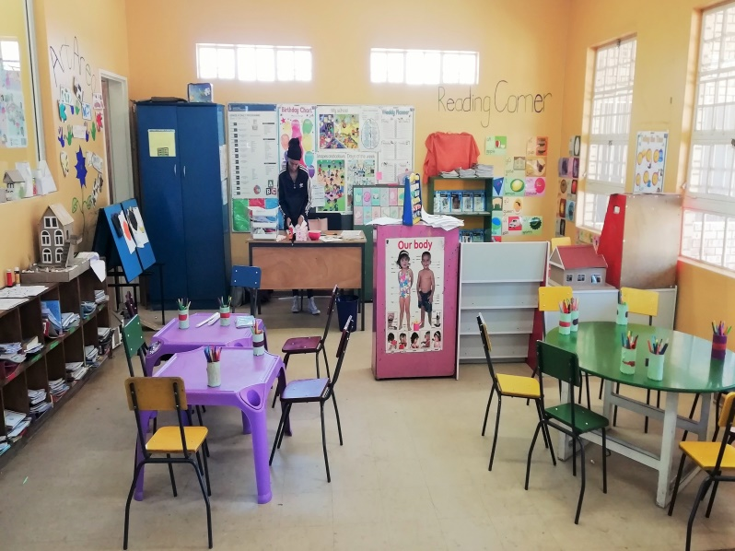
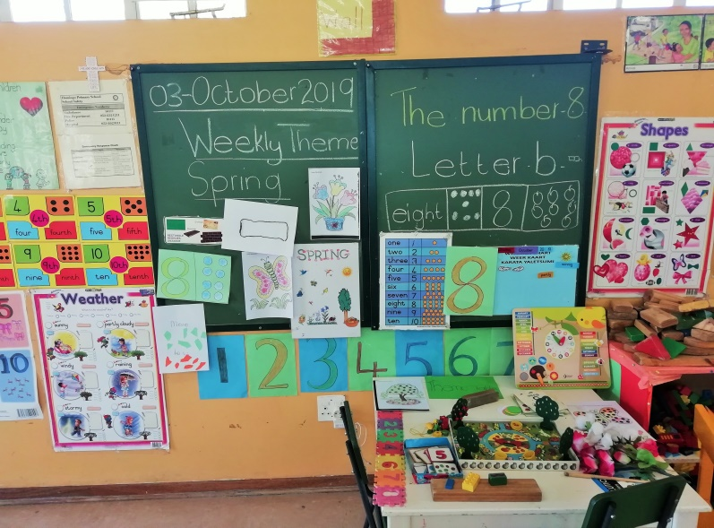
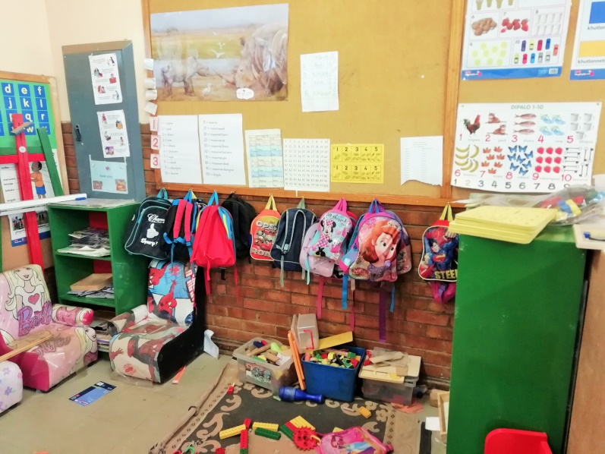
Examples of well-resourced and structured Grade R classes
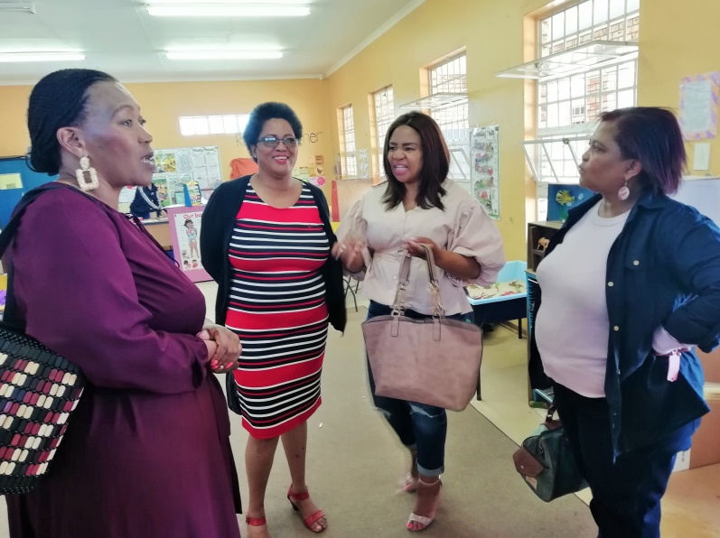
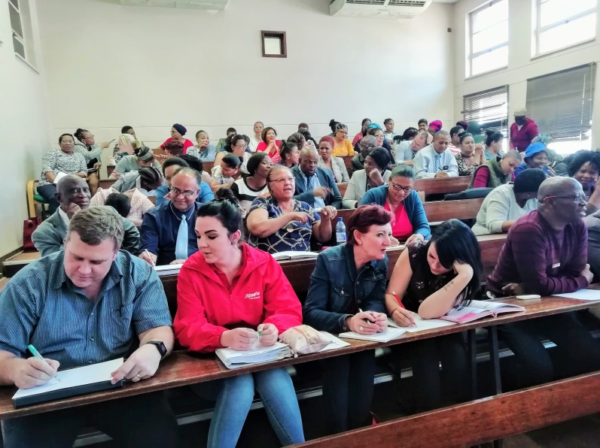

Provincial and District Officials Advocacy Meeting for Principals, HODs and teachers
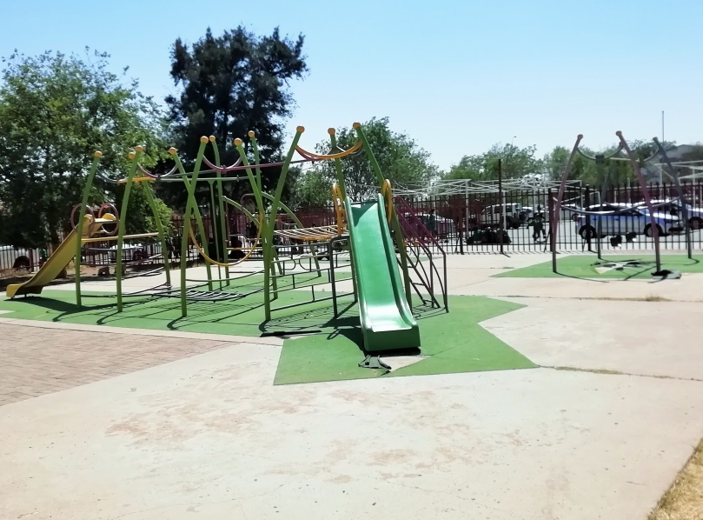
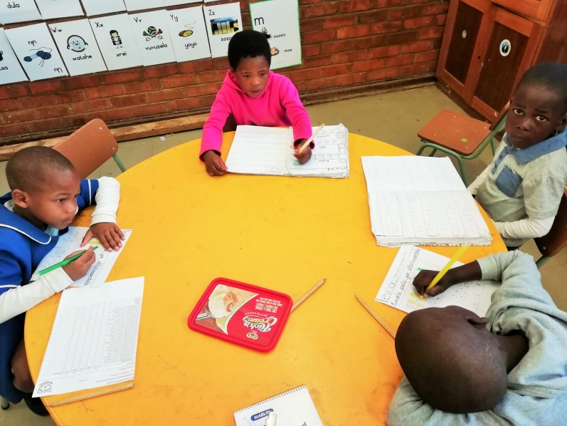

Grade Rs doing a group activity Playground at one of the schools

Potential Opportunities and Challenges:
Opportunities: +
- It was evident from this visit that the Provincial and District Officials, teachers and schools leadership are interested in the project and looking forward to its implementation next year.
- The Provincial and District Officials gave their full cooperation during the visit and have already been able to identify schools and teachers for the project.
- The schools in the district seem well-suited to implement the BCP inside their classes.
- The schools that have been identified are easily accessible and also diverse which makes for an interesting and potentially rich environment for learning.
- Two volunteers have already been identified and have shown an interest in participating in the project.
- Phase 2 of the project has been given the full backing of the district director and ECD head.
Challenges: -
- It will be important to finalise the teacher list and to exclude teachers who might not be able to commit to the project for 2 years.
- The logistics for the start of the project next year need to arranged timeously before the start of the new year – These arrangements can take time to be formally approved.
- The heavy workload of the department officials might make it difficult for them to give the project their full attention – The role of the volunteers is thus essential to assist with teacher mentoring and school visits.
- The notification of schools and their formal agreement to participate in the project are essential to avoid any potential conflicts and to gain ready access to schools and classes.

Conclusion:
This was a most successful initiation visit to the Frances Baard Education District. All objectives of the visit were met. The Basic Concepts Project Team looks forward to the start of Phase 2 of the project early in February 2020. It is our belief that if a project is well organized from the start and its participants have been appropriately canvassed and engaged, the chances for success are greatly enhanced. It is our hope that we will attain the objective of significantly improving the language, thinking and learning potential of Grade R learners in the district and making a contribution to their improved literacy and numeracy in the Foundation Phase. We are most thankful to all the officials who assisted with this visit and paid such close attention to all the logistics for this visit.

APPENDIX 1

Exploratory Visit to the Frances Baard, Northern Cape (2019)
Visit Date: 2nd October 2019 + 3rd October 2019
Venue: Kimberley, District Office

PROGRAMME FOR ORIENTATION VISIT

2nd October 2019
- Meeting with District Leadership (9:00-10:00)
- Planning Meeting with district officials – see agenda below (10:30-12:30)

Agenda for Planning Meeting

- Confirmation of the dates for the implementation of the project in 2020-2021
- Core Planning for the project:
  - identification of teachers and schools:
  - logistics for training: numbers (teachers, officials, volunteers) + venue, equipment, travel , food and accommodation
  - follow-up support visits : frequency of visits, travel arrangements, volunteers
  - protocols to gain access to schools/classes and introductory letter
- Other planning aspects: BC Workbooks, Groupings, Placement of BCP in the school day, etc.
- Volunteers:
  - Roles and responsibility of volunteers
  - Identification and selection of volunteers
  - Oversight of volunteers
- Research:
  - research process and time line
  - selection of the schools (control = 5 and experimental = 5)
- Contextual issues: What do BCU need to know about the territory – petrol, autobanks, restaurants, accommodation, shops, emergency services, condition of roads, etc.

3rd October 2019
- Visit to the nearest 3 schools, a tour of the surrounding areas , and to possible training venues (8:00-11:00)
- Advocacy meeting with school representatives (12:00-13:30)
- Meeting/Interviews with prospective volunteers or planning meeting to discuss the recruitment of volunteers (13:30 – 14:30)
- Summation meeting with district and provincial officials (14:30 -15:30)

