BC ADVOCACY PROJECT: PHASE 1 (2019-2020)
Pixley Kaseme Education District

Field Visit 2
27 – 31 May 2019
Aims of Visit
- To continue training the project teachers, officials and volunteers. This was achieved by giving two days of training in the third and fourth conceptual domains of Size and Position.
- To continue mentoring and supporting teachers in their practice of the Basic Concepts Programme (BCP) by spending three days helping them with the BCP in their classrooms. Teachers were encouraged to continue implementing the BCP and to start with the new domains before the next training. (The third and final round of training, for conceptual domains of Number and Letter, will be conducted during the next visit.)
- LENA devices trial: A trial of several LENA Devices (Language Environment Analysis) was undertaken in both districts (Pixley Kaseme and John Taolo Gaetsewe). These were loaned to Basic Concepts Unlimited by the Department of Global Health and Innovation Edge. The outcomes of the trial will determine the feasibility of a follow-up trial later in the year and the possibility of a research study using the devices during 2020. Feedback about the devices will be given once the outcomes of the trial are available.
See the programme at the end of the report for a full breakdown of activities during this visit to the project.

1. Feedback from Training Sessions
Training Statistics-
Attendance | Training Day 3: Size | Training Day 4: Position
Number of practitioners | 41 out of 44 | 41 out of 44
Number of local district officials | 1 out of 1 | 1 out of 1
Number of provincial & trainee officials | 2 out of 2 | 2 out of 2
Number of volunteers | 2 put of 4 | 2 out of 4
Number of other attendees | n/a | n/a
Total | 46 | 46

Comments on attendance statistics –
- One of the absent teachers had exams. Two of the volunteers could not attend as distance and cost of travel were prohibitive for them. This was a pity and Louis said that if they inform us well ahead of the time we can perhaps help with funding.

Analysis of qualitative feedback -
- Both days of training were well-received and the feedback was overwhelmingly positive. Many comments reflected the highly interactive nature of the training: they enjoyed learning from each other and the facilitator, being given opportunities to practise the BCP with colleagues, and have their concerns, thoughts, ideas and questions heard, discussed and addressed.
- Verbatim comments: Size
- My learners are not the same as before the Basic Concept had started.
- I really liked the fact that we were able to interact with each other a lot and exchange ideas. We were all actively engaged.
- I learnt how practitioners can introduce size in different ways to learners. Size is about match, compare and measure.
- It was a good session as we were given ideas about how to mediate size and to ask relevant questions so that children can explain themselves better.
- The session was not just theory, it was very practical.

- Verbatim comments: Position
- It was interesting to learn more vocabulary around position and strategies to teach the learners.
- The presentation was interesting. The children will enjoy the activities.
- There was so much about position that I did not know and that I learnt today.
- I really enjoyed learning about ways to teach my learners about left and right. I also learnt a lot from my colleagues about how they do things in their classrooms.
- I really liked the session about what BCP suggests we should do and not do in class. We do things in class not really knowing that we shouldn’t do them, e.g. labelling learners which can negatively affect their thoughts about themselves.

General Comments about the training sessions –
- The same spacious venue in De Aar again proved a good choice. Most teachers participated actively, discussing and learning from each other. They were motivated and eager to learn so that they can help their learners become school-ready.
- The practitioners enjoyed contributing and being actively involved. I would recommend that the next training is just as interactive, allowing for many opportunities for the exchange of experiences, ideas, thoughts and best practice.

2. Mentoring Teachers and Training Officials/Volunteers to Support
Visit Statistics-
- Number of schools visited out of the total number of project schools: 5 out of 19
- Number of teachers visited out of the total number of teachers: 14 out of 44
- Number of officials who were part of the visits over 3 days: 3 officials per day
- Number of volunteers who took part in the visits over 3 days: 3 volunteers over 3 days

Overview of the school visits-
- The teachers were visited by one of two teams consisting of district and/or provincial officials and/or project team members and volunteers (2/3 members per team). Shaheeda Kamalie-Mali, Senior Education Specialist and co-ordinator of the BCP in the De Aar district, arranged the school visits. The teams would leave from De Aar each morning to visit teachers and together discuss their feedback in the afternoons.
- The classrooms were mostly adequately equipped, spacious enough and suitable for effective teaching and learning. Some do need new mats or a coat of paint, but generally, they were sufficiently resourced. We were informed that there is a policy that not all learners in Grade R should be sitting at tables and therefore some of the classes did not have a table and chair for each child.
- All the teachers had their BCP teaching concept poster on the wall, workbooks for their learners (with completed work), relevant theme tables and BCP admin files. All had completed the first conceptual domain of colour and most had completed the second domain of shape. Many started on Size immediately after the training.
- While the majority of teachers were evidently doing the BCP regularly, others were not doing it enough and the latter need strong encouragement and further mentoring to facilitate the consistent implementation of the programme. It was pleasing to see that there are teachers that are mediating well and have a good understanding of the programme. This is evidenced in their learners who have a sound grasp of the concepts, are using full sentences and appropriate conceptual vocabulary. Most of the teachers fall into the ‘average’ category, where they are getting to grips with the BCP and the mediational approach but perhaps have not fully mastered either yet. Overall, most teachers are mediating the BCP with some degree of success.

Mediational/teaching environment-
- The overall feedback indicated that 60-70% of the teachers had a good to adequate grasp of the BCP and mediation. These teachers were familiar with the steps of the teaching model and mediational teaching.
- About a third were still not fully conversant with the BCP steps and are still using the transmission-based teaching approach (where learners repeat after the teacher as a group) but after being reminded how to mediate, attempted this approach successfully. In these cases follow-up mentoring visits in the near future were recommended. Their learners continue to need encouragement to use full sentences and to respond individually with self-initiated ideas (instead of just repeating after the teacher).
- More than half of the learners we saw had a good understanding of their colours and shapes, the conceptual domains that have already been done.
- Feedback given to the teachers related to the following:
  - Workbooks could be more creative with less photocopied material and more of the learners’ own input, drawings, etc.
  - BCP admin files need to be completed properly. The teachers were shown how to do this.
  - Continue to ask open-ended questions, encourage and model the use of conceptual vocabulary and full sentences.
  - Encourage individual thought and responses and allow time for these.
  - Spend more time on specific steps if the learners are not ready to continue.

Department of Education: District and Provincial
- There were numerous meetings and contacts with the DoE officials during the visit. After the daily school visits there was a feedback session with the project team, including the officials.
- Officials are very positive about the project and willing to help wherever they can.

Volunteers
- The district now has four volunteers, three of whom are well-entrenched in their roles and have been visiting teachers and giving feedback. Two volunteers attended the training and, as previously mentioned, the other two were restrained by costs of accommodation and travel. This was addressed for future training.
- The volunteers actively contributed to both training sessions. They accompanied the project team to schools and appeared to have good insight and are highly motivated.
- Issues such as appointing a possible co-ordinator (decided against), petrol costs (will be reimbursed), reporting, invoicing, and allocation of teacher visits were discussed.

Mrs. Japhta -Van Rensberg Primary School - Britstown
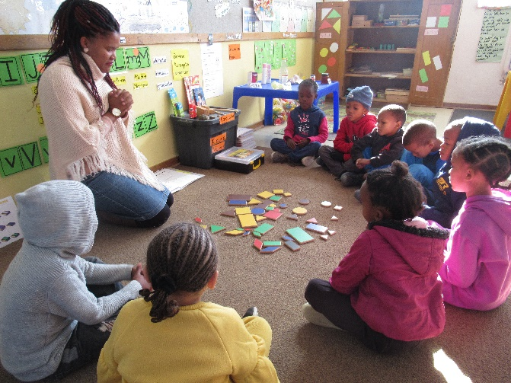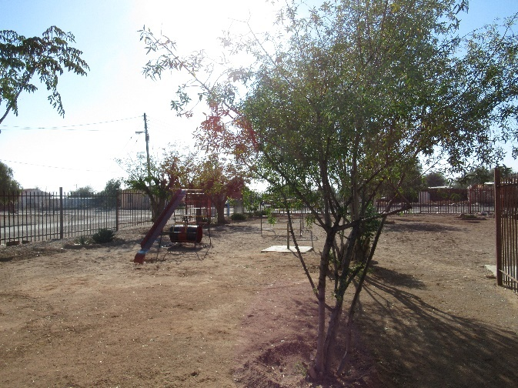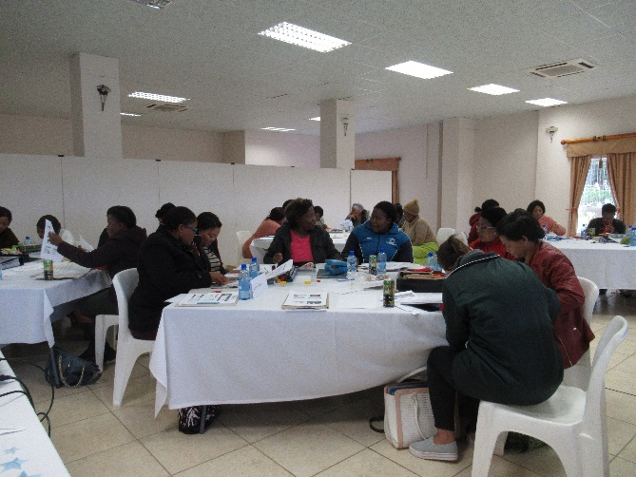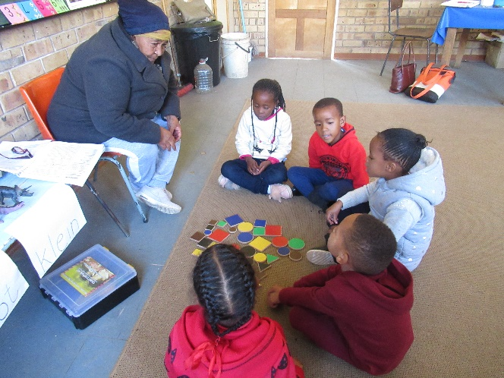
Training Mrs Louw – Lowryville Primary - Colesberg

Summary and Conclusion
- The BCP continues to gain traction in the Pixley Kaseme district as more teachers implement it on a regular basis and start mastering the programme.
- There are, however, some teachers that require further ongoing support and encouragement. The volunteers and officials will play a vital role in mentoring them. The What’s App group will also continue to play an important role in assisting us to communicate with and encourage the teachers.
- The enthusiastic support and assistance given by the Northern Cape Department of Education is very encouraging. We are hopeful that the project will not only upskill many of the educators and change the way they teach, but also help their learners be better prepared for school and thus improve their chances of academic success.

Appendix 1
Basic Concepts Advocacy Project: Phase 1 (2019 – 2020)
Pixley Kaseme and JTG
Programme for Visit 2: 27 – 31May 2019
DATE | Activity | Participants | Time | Comments/Notes/Aims
27 May | Training | All practitioners, volunteers and officials | 8:00 – 16:30 (registration at 7:30) | Teachers to bring their files and a selection of workbooks with them. We only need 6 kits and pictures sets for the training. Workshop evaluation to be completed at the end of the training.
28 May | Training | All practitioners, volunteers and officials | 8:00 – 16:30 (registration at 7:30) | Teachers to bring their files and a selection of workbooks with them. We only need 6 kits and pictures sets for the session. Workshop evaluation to be completed at the end of the training.
29 + 30 May | School Visits | Number of visit teams: 2  Number of visits per team: 7  Total number of visits: 14 | 8am to the end of school day | 30-40 minutes per class visit. The focus of the visits should be on SIZE, but also briefly review SHAPE at the start of each session for 5-8minutes.Teachers not visited can be visited by volunteers after the visit.
29 + 30 May | Visit feedback at the district office | Officials, Volunteers and Project Team | 14h00-1600 | All class visitors bring their completed observation sheet with them to the feedback meeting to give feedback on their visits. Each person on the visit team should take responsibility for reporting back on at least one visit.
29 May | Meeting with District Officials | Project Team and District | 16h00-17h00 | To discuss planning for the way forward: teacher support, volunteers, dates for next visit, add new participants to what’s app group, etc. Take notes at this meeting.
30 May | Meeting with Volunteers | Volunteers, District Officials and Project Team | 16h00-17h00 | To get feedback from volunteers and to plan the next set of visits to the teachers. Attempt to clarify and sort out any problems or make a note of these. Elect a volunteer coordinator. Discuss the new observation sheet. Etc.
31 May | School Visits | Officials and Project Team | 7:30-10am – early start to get to schools at the start of the day | This is a shorter day and only limited visits to allow the project team and officials time to get back home by the end of the day. The local officials may continue with the visits after the project team has left.

