BC ADVOCACY PROJECT: PHASE 1 (2019-2020)
Pixley Kaseme Education District

Field Visit 1
04 – 08 February 2019

- Aim of visit: This was a training and mentoring visit. See Appendix 1 for the programme with a full breakdown of activities during this visit.

- Mentoring Teachers & Training Officials/Volunteers to Support:

Visit Statistics
- Number of schools visited: 8 (out of a total of 19 project schools)
- Number of teachers visited: 17 (out of the total of 44 teachers)
- Number of officials who were part of the visits over 3 days: 3
- Number of volunteers who to took part in the visits over 3 days: 0

Overview of the school visits
- Shaheeda Kamalie-Mali, Senior Education Specialist and co-ordinator of the BCP in the De Aar district, arranged the school visits. Four of us (Diane Goldsmith, BCP trainer; and 3 officials) visited teachers. Three were experienced with BCP but one was a new official from ZF Mgcawu District who is being trained parallel to the implementation of BCP in PK District (Mrs Nonkosi Lapie – Senior Education Specialist from Upington). She will need to attend all the training sessions. The other two officials were Yvonne Louw, Deputy Chief Education Specialist from the head office in Kimberley and Shaheeda Kamalie-Mali from De Aar. The volunteers were unfortunately unable to join us. See Appendix 2 for the list of schools and teachers.

- The Grade R classrooms were neat and mostly well-equipped. At John Rossouw in Victoria West two of the classes did not have enough chairs and tables for the children. They also need things like posters for the walls and other educational games, material, etc. The playground at this school is sandy and it is sparsely equipped. See photos below. The headmaster commented that they would like to put down artificial grass. Another school playground, despite the school’s best efforts, that looks sad, is Alpha Primary.

- All the principals were positive about the BCP. We gave each one a recent BCP newsletter and encouraged them to look at the BC website. As the training had only just been completed these teachers were doing the BCP for the first time. It is not surprising that some of them were nervous and a bit lost at times, but a few did very well, especially considering that they are not experienced BCP mediators. The practitioners were positive and enthusiastic about the BCP and motivated to implement it. Many were encouraged when they saw that the children were enjoying the BC session and that it can be fun, interesting as well as educational.

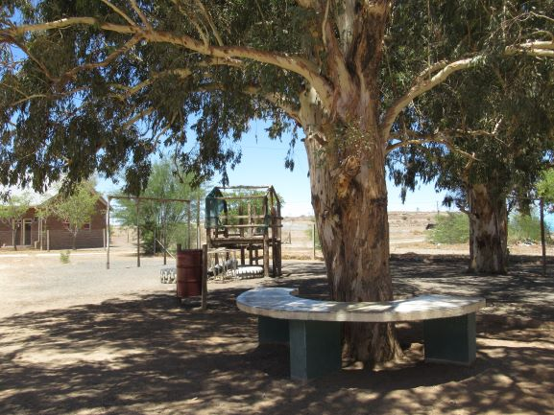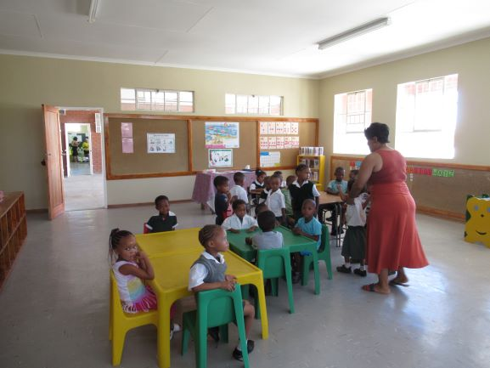
John Rossouw Primary - Victoria West 1
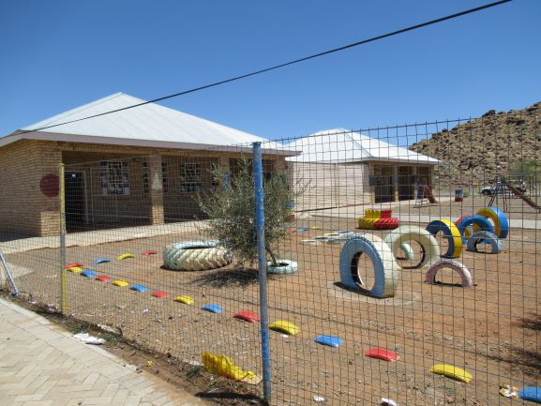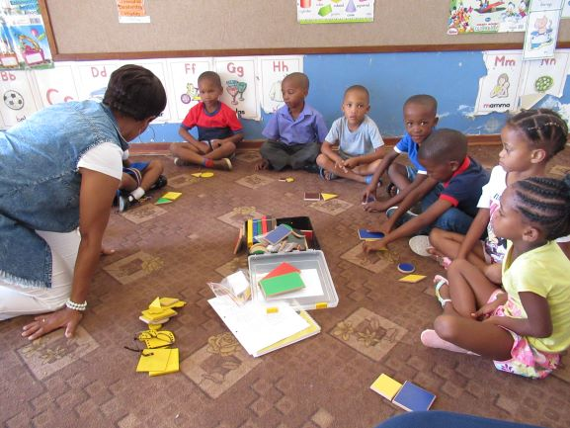
Alpha Primary - De Aar 1
Mediation/Teaching
- The teachers had not had time to prepare or practise as they were newly trained. They did, however, have an opportunity during the training to write out the colour yellow session planner. All had placed their BCP model on the wall and all bar one had workbooks although they had not yet started using them. For most of these teachers, consciously using mediation as a methodology is a new approach to teaching and it will take time to hone this skill properly.
- All the teachers encouraged their learners to use full sentences. Most used the Lower Order Concept (LOC) “Yellow’ a lot but some had to be reminded to use the Higher Order Concept (HOC) ‘Colour’ more. There were some that asked relevant open-ended questions but some defaulted to the use of instructions and had to be reminded to ask open-ended questions, and then allow time for learners to think and respond.
- There were a few teachers that did not initially focus on only one colour but mixed in shape as well. We reminded them to focus on one HOC at a time.
- Most of the practitioners could roughly follow the steps although there were a few that needed a lot of help. The majority did not do Step 2 (Identifying) and Step 5 (Application) properly but these are the most difficult steps.
- Recommendations given to most teachers included:
- Use the HOC and LOC terms a lot.
- Spend more time on Steps 2 and 5 as these were the steps that most children struggled with. Step 2 involves identifying the LOC by matching and comparing colours (different colours and shades of a colour by using vocabulary such as ‘the same as’, ‘different’, etc.); and establishing associations (whether it is a bright/dull colour, a warm/cool colour; and naming things that are typically that colour like the sun, bananas, lemons, egg yolks, yellow vests, etc.). Step 5, Application, involves applying their knowledge to sorting and grouping the different colour blocks and learning the concept of categorization.
- Make up interesting stories for Step 3 and ask the children if they are visualising the yellow flowers, can feel the hot sun on their skins, etc.
- Ask open-ended questions and allow learners time to think, consider and answer using full sentences.

Department of Education (district and provincial)
- Shaheeda, Yvonne, Nonkosi and I had daily discussions/meetings, some informal and others formal. After our daily school visits, we gave feedback and discussed how the teachers mediated their sessions.
- Shaheeda and I were in contact before, during and subsequent to the training and I’m sure we’ll build on this strong foundation. We have a good understanding and she is enthusiastic about BCP and very willing to help.
- WhatsApp groups for the officials and the practitioners have been set up to ensure regular contact and encouragement. Teachers have been posting lovely photos of their learners doing BCP-related activities.
Volunteers
- Two volunteers attended the training. They were very quiet during the training but said they enjoyed it. Neither of them, however, joined us on the school visits. One’s sister died and the other one relied on the first one for transport. Shaheeda asked them to join her on school visits during the next few weeks and will then assess the situation. It’s a pity that they missed the first school visits but hopefully they will join Shaheeda and soon become competent.
- Shaheeda has recently found another volunteer. As the distances are vast the reimbursement for travel costs will need to be considered.
- An alternative option is to hire just one volunteer who can visit all the schools instead of having to manage multiple people.

Summary and Conclusion
- The training was well received with positive feedback given. The teachers were enthusiastic -about the BCP - and the fact that they were learning new skills that would help their learners have a better chance at academic success.
- As new mediators, the teachers will need much support and daily practise. With experience, help and encouragement, they should all grow in their BCP mediation.
- It will take time for the volunteer programme to be fully operational. Any additional volunteers will need to be trained and accompany experienced mediators on school visits so that they can become competent enough to facilitate BCP sessions, advise and assist teachers.
- The WhatsApp group is already proving a success. Teachers are receiving guidance, ideas, and being motivated and encouraged by others.
- The BCP has started off successfully in the Pixley Kaseme district and with the right support and future training it should continue to gain traction. We hope that all the trained practitioners will become highly competent BCP mediators and excellent teachers because of the skills they have gained through their mediation practice.

Appendix 1
Basic Concepts Advocacy Project: Phase 1 (2019 – 2020)
Pixley Kaseme and JTG
Programme for Visit 1: 4 – 8 February 2019
DATE | Activity | Participants | Time | Comments/Notes
4 Feb | Training | All practitioners, volunteers and officials | 8:00 – 16:30 (registration at 7:30) | Learners required for the demonstration session at around 13h30
5 Feb | Training | All practitioners, volunteers and officials | 8:00 – 15:00 | Learners required for demonstration session at around 13h30. Workshop evaluation to be completed at the end of the session.
6+7 Feb | School Visits | Number of teams: 2  Number clusters to be visited: 4  Number of teacher visits per morning: average of 6 | 8am to the end of school day | 30-40 minute per class visit. It is better if the teachers visited are clustered closer together. I would like to aim to visit at least half the teachers per district. Teachers not visited can be visited by volunteers after the visit.
6+7 Feb | Visit feedback | Officials -Project Team (Volunteers could not make visits or meetings) | 14:00-16:00 | All class visitors bring their completed observation sheet with them to the feedback meeting to give feedback on their visits.
6 Feb | Meeting with Volunteers. Did not take place as volunteers were not present. | Volunteers, District Officials and BCP Trainer | Volunteers were not present therefore this meeting did not take place. | A session to cover all issues that might be relevant to volunteers, but should include discussions about their role in the classes and reporting requirements. Contracts should be signed and handed in. Go into more depth about the Obs Sheets.
7 Feb | Meeting with District Officials | BCP Trainer and District Officials | 13:30 – 15:00 | To discuss planning for the way forward: teacher support, volunteers, dates for next visit, set up whats app group, etc.
8 Feb | School Visits | BCP Trainer and Officials | 7:30-10am – early start to get to schools at the start of the day | This is a shorter day and only limited visits to allow the project team to get back home by the end of the day.

