

BC ADVOCACY PROJECT: PHASE 1 (2019-2020)
John Taolo Gaestewe Education District

Field Visit 2
27 – 31 May 2019

Aim
The main purpose of this visit was to continue with the training and support of the teachers in the project. The project teachers, officials, and volunteers received their second round of training over two days as well as follow up visits to their classes on the following 3 days. The visit was a week in duration.
The teachers were expected to have continued implementing the Basic Concepts Programme in their classes and are expected to implement the conceptual domains of Size and Position before the next training and mentoring visit.
The main purpose of this report is to provide feedback from the two training days as well as the follow up/mentoring visits to the teachers and to give an overview of the current status of officials and volunteers.
During this visit a pilot trial was undertaken in both districts (Pixley Kaseme and John Taolo Gaetsewe) which made use of LENA (Language Environment Analysis) devices. The LENA Devices were loaned to Basic Concepts Unlimited by the Department of Global Health and Innovation Edge. The outcomes of this pilot trial will determine whether it is feasible to do a follow-up trial later in the year and ultimately a full research study using the devices during the second year of the project. No further feedback about the devices will be given in this report, however this will happen once the findings of the trial are finalised.
See the programme at the end of the report for a full breakdown of activities during this visit to the project.
1. Feedback from Training Sessions

Training Statistics-
Attendance | Training Day: 3  Size | Training Day: 4  Position
Number of practitioners | 39 out of 41 | 34 out of 41
Number of local district officials | 3 out of 3 | 3 out of 3
Number of provincial and trainee officials | 4 | 4
Number of volunteers | 2 out of 2 | 2 out of 2
Number of other attendees | *2 | *3
Total | 50 | 46
*Note: Two new prospective volunteers attended the training sessions as well as an HOD from
one of the schools.

Comments on attendance statistics –
One of the project teachers had been promoted to the Foundation Phase and thus did not attend. There was also a new teacher who attended as a replacement for another teacher at her school. There was thus one less teacher (41 not 42) and one less school (18 not 19) in the project. Two teachers were not able to attend the entire training- one of the teachers was in hospital, while the other teacher was on study leave. Another teacher was on study leave during the 4th training session. One school was not able to attend the final session because of transport problems. There were also 3 teachers who left the 4th training session early (after lunch) because of exams.

Feedback From Session 3: Size
While the overall feedback for the session was highly positive, there was also some critical, but helpful feedback about the session. These comments mainly related to the noise levels inside the venue during the workshop, the length of time that it took for everyone to arrive, and the cold temperature inside the venue. The main positive trends were related to the trainer’s approach as well as the practical and hands-on nature of the workshop. The teachers also gave some feedback about their initial feelings/experience of the programme.

Verbatim Comments
- ‘What I liked is that we did size practically in the class / workshop.’
- ‘We do not have to guess the size; (rather) we should match, compare and measure, to find out about the size.’
- ‘Ek het geleer dat jy meer as een grootte MOET he om ‘n vergelyking te kan maak.’
- ‘Dat leerders self tot die slotsom moet kom van Grootte – nie vir hul “spoon feed” nie – bv. Deur vir hulle te se: ‘die blok, sirkel is groot of klein’. Leerders moet self uitvind deur te vergelyk – compare, te pas – match and te meet – measure.’
- ‘I liked the way that he presented the lesson to us… he was very active and made the learning very interesting.’
- ‘Ek het van die praktiese gedeelte die meeste gehou omdat ek kon meer leer hoe om dit oor te dra aan die kinders.’
- ‘I love everything about basic concepts because I am not the only one who is benefiting, my children are also benefiting, and they are learning a lot from it.’
- ‘This training is very important to me as a mediator because my children are improving.’

Feedback From Session 4: Position
Most of the feedback about the training session was very positive, but there were also some critical comments. The main difficulties experienced by teachers again related to noise levels inside the venue, concerns that they needed more time to learn about the domain, and fears about the forthcoming class visits. The positive feedback suggested that the workshop had enabled participants to start to navigate a domain they had initially felt unfamiliar with. Following the workshop, participants seemed to grasp the Position concept and expressed a willingness to implement this in their classes.

Verbatim Comments
- ‘The learner should have a working understanding of concepts of position and be able to locate himself within a spatial context in relation to others.’
- ‘I learnt how to teach learners about position so that learners can improve their vocabulary.’
- ‘Ek het geleer dat om posisie te leer moet die leerders almal in ‘n reguit lyn sit of dieselfde “angle” kan sien.’
- ‘I have learnt some things/some words for the first time in my life.’
- ‘I liked position even if it is difficult.’
- ‘Ek het die praktiese gedeelte geniet, waar ons moet oefen en hoe ons BKs met die kinders gaan implementeer.’
- ‘Die praktiese gedeelte het ek baie geniet dit was baie leersaam en ek sal dit gaan toepas.’
- ‘Jy leer elke dag iets, jy’s nooit te oud of slim om kennis te ontvang.’

General Comments about both the training sessions –
The two days of training were highly successful, even though there were numerous logistical issues that needed to be addressed, particularly on the first day of the training. The training started late because of late notification of the venue details and the distances that some teachers had to travel. In addition, there were many teachers who were busy with exams which impacted both directly and indirectly on the training. Improvements need to be made to the planning of future training sessions which should greatly enhance the quality of the experience for everyone involved. A refresher about position will be provided to teachers when they start with this domain in the third term.

2. Mentoring Teachers and Training Officials/Volunteers to Support

Visit Statistics-
- Number of schools visited out of the total number of project schools: 15 out of 18
- Number of teachers visited out of the total number of teachers: 23 out of 41
- Number of officials who were part of the visits over 3 days: 7 officials per day
- Number of volunteers who took part in the visits over 3 days: 2 volunteers per day

Overview of the school visits-
- The teachers were visited by one of four teams consisting of district and/or provincial officials and/or project team members and volunteers. The teams were each comprised of 2 to 3 members. The teams left Kuruman each morning to visit teachers and returned in the afternoons to give feedback at a combined group meeting.
- An official from the Frances Baard district, who had not been trained during the previous project, accompanied the project teams on their visits and for the feedback meetings in the afternoons as part of her training.
- The teachers who have not yet received follow up visits will receive their visits at the start of the third term. These were mostly teachers who were busy with their exams at the time of our visit.
- A key observation from the visits related to improvements in the physical environment of the classes - The classes have started to look more like Basic Concepts classes. (See pictures below.) Apart from theme tables and posters of the teaching model which have been noted previously, there were also posters of the learners’ work on the walls and even a few vocabulary walls. Teachers had not been specifically requested to do this but had taken initiative and gone beyond the brief to enhance the physical environment of their classes.

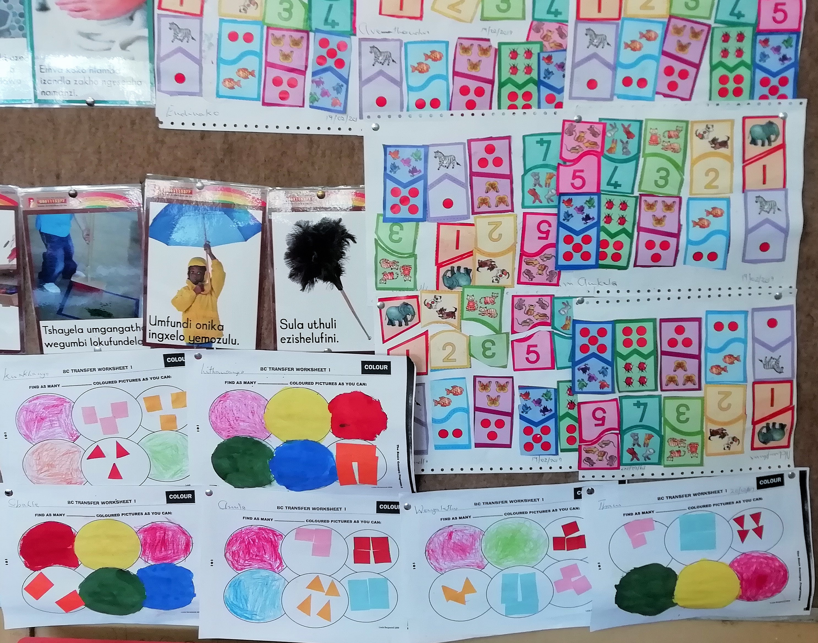
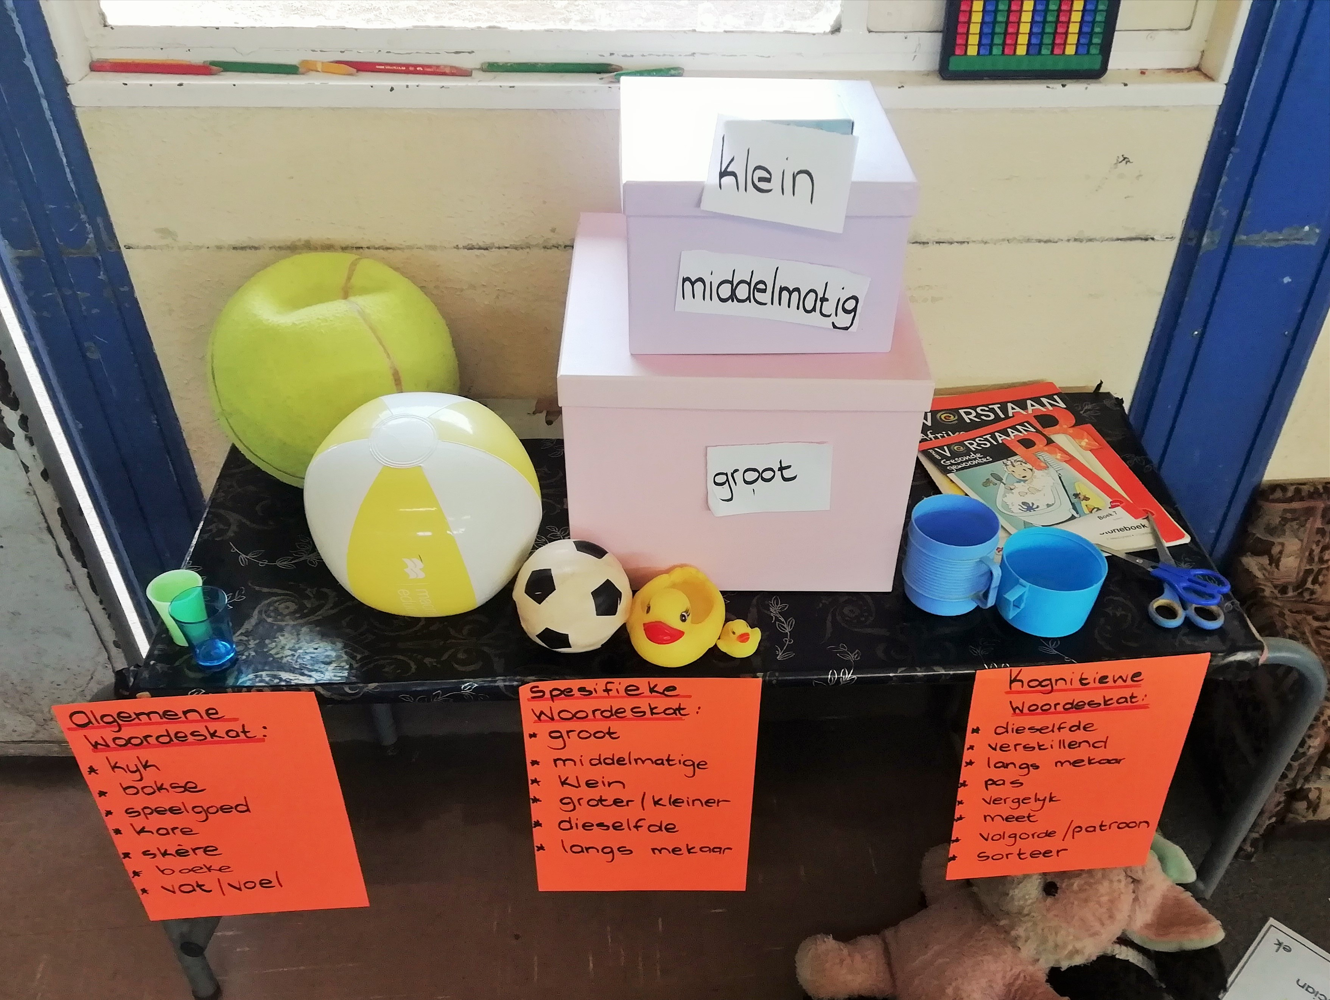

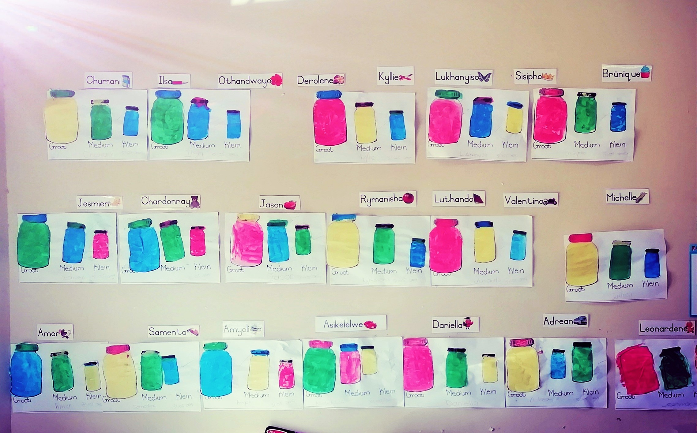

- The teachers visited were all prepared for their sessions and had a completed Session Planner with them during their session. The teachers willingly demonstrated, and seemed more comfortable with the observers during this visit than the first visit.
- It was also evident that the teachers had internalized and were aware of the main ethos of the approach and could verbalize some of the main principles of the approach. For example, teachers would often remind their learners to speak in full sentences and we in fact frequently started to hear learners make use of their conceptual language for colour and shape. See the section below for more detail.
- We did however find that the majority of teachers, though aware of the need to run the programme daily with their learner groupings, were not running the programme as regularly as recommended. It was not possible to determine the exact frequency of implementation, but most teachers were willing to admit they were not implementing as often as they could.
- The learner workbooks were present in most classes and when there were no learner workbooks (in very few cases) there were files with the learners’ work. The workbooks/files contained work for the domains of colour and shape, but this was not always adequate in quantity or quality. This was particularly true for the work done for the domain of shape.

Mediational/teaching environment-

- There had been a shift in the teaching/mediation in the majority of the classes visited and only in a minority of classes were concerns raised about the teachers’ application of the approach. There was greater familiarity with the steps of the teaching model and the mediational approach of the programme. Visitors to the classes noted significant improvements in teacher mediation from Visit 1 to Visit 2.
- Teacher questioning routines have become a more common feature in these classes - the teachers have become much more explicit in their approach. There were consequently fewer reports of teachers encouraging and leading group recitations of information.
- The level of discussion around the teachers’ role in the classroom had also shifted and often included more nuanced issues, for example how teachers could start to encourage more children to participate during the sessions and not only focus on those who might dominate the discussions.
- Several classes with higher levels of learner fluency and teachers who were mediating more effectively were flagged, while in most classes there were only moderate levels of learner talk. These learners still needed some encouragement to start to respond.
- There was a concern raised about the newcomers to the project and also about the younger teachers who seemed to lack confidence during the demonstration sessions.

Department of Education: District and Provincial
- There were two formal contact sessions with all the project officials and the volunteers, one meeting with the local district officials, and another meeting with the local district officials and volunteers. Minutes of decisions were recorded at these meetings.
- The meetings were all held in good spirits and there was greater understanding between the participants than that experienced during the first round of meetings in Visit 1.
- The officials were motivated to deepen their learning about the approach and also showed a commitment to the process. For example, the officials asked many more detailed questions during the feedback sessions and became involved in a hands-on-way with the teachers during the demonstration sessions.

Volunteers
- The two volunteers who started at the beginning of the project have continued to support the project. They attended both the training sessions, accompanied us on the class visits, and attended the feedback meetings.
- The volunteers have provided excellent follow-up and support to the teachers and have completed two rounds of visits to them. Another round of volunteer visits has been scheduled before our next visit to the project in August.
- Closer volunteer collaboration with each of the local district officials has been discussed and agreed upon.
- No new volunteers were engaged during this visit. The current volunteers appear to be coping well with the support visits at the moment.

Summary and Conclusion
The Basic Concepts Advocacy Project has started to take root in the district. Teachers have started to mediate with more confidence and knowledge of the process and their learners have started to respond, albeit a bit hesitantly. We have found an almost universal implementation of the programme since the start of the project, even though some teachers have required a firmer approach. The most pleasing component of this visit was the transformation (mostly unprompted) of the physical settings inside the classes into Basic Concepts classes. While we were encouraged with the progress and deepening of the practice of the teachers, we would still recommend the teachers to increase the weekly number of sessions and output in the workbooks.

We are very pleased with the constructive role that has been played by volunteers in supporting the teachers and keeping the project team updated on developments inside the classes. The local district officials and volunteers appear to be working well together, but could coordinate and collaborate better with each other. Specific teacher interventions may be needed to assist some teachers.

The What’s App project group for the district has grown from 22 members to 33 members with only a few schools that are not yet covered by the group.

The provincial officials remain fully committed to the project and we are grateful for their enthusiastic support.



APPENDIX 1
Basic Concepts Advocacy Project: Phase 1 (2019 – 2020)
Programme for Visit 2: 27 – 31 May 2019
Pixley Kaseme and JTG
DATE | Activity | Participants | Time | Comments/Notes/Aims
27 May | Training | All practitioners, volunteers and officials | 8:00 – 16:30 (registration at 7:30) | Teachers to bring their files and a selection of workbooks with them. We only need 6 kits and pictures sets for the training. Workshop evaluation to be completed at the end of the training.
28 May | Training | All practitioners, volunteers and officials | 8:00 – 16:30 (registration at 7:30) | Teachers to bring their files and a selection of workbooks with them. We only need 6 kits and pictures sets for the session. Workshop evaluation to be completed at the end of the training.
29 + 30 May | School Visits | Number of visit teams: …….  Number of visits per team: …….. ……… ………. ……… …….. ……….  Total number of visits: ……. | 8am to the end of school day | 30-40 minutes per class visit. The focus of the visits should be on SIZE, but also briefly review SHAPE at the start of each session for 5-8minutes.Teachers not visited can be visited by volunteers after the visit.
29 + 30 May | Visit feedback at the district office | Officials, Volunteers and Project Team | 14h00-1600 | All class visitors bring their completed observation sheet with them to the feedback meeting to give feedback on their visits. Each person on the visit team should take responsibility for reporting back on at least one visit.
29 May | Meeting with District Officials | Project Team and District | 16h00-17h00 | To discuss planning for the way forward: teacher support, volunteers, dates for next visit, add new participants to what’s app group, etc. Take notes at this meeting.
30 May | Meeting with Volunteers | Volunteers, District Officials and Project Team | 16h00-17h00 | To get feedback from volunteers and to plan the next set of visits to the teachers. Attempt to clarify and sort out any problems or make a note of these. Elect a volunteer coordinator. Discuss the new observation sheet. Etc.
31 May | School Visits | Officials and Project Team | 7:30-10am – early start to get to schools at the start of the day | This is a shorter day and only limited visits to allow the project team and officials time to get back home by the end of the day. The local officials may continue with the visits after the project team has left.

