DELTA PRIMARY TEACHER PROJECT
BC SUPPORT FORUM 2015
Meeting 2: 21 September 2015
Time: 14h15 – 15h15
No of teachers: 14 – One teacher could not attend the session because she was at another meeting (See register)
Main Focus: To provide a refresher of the core components of the programme/approach and to encourage teachers to start to use the programme/approach inside their classes.
Handouts/Resources: Four additional teacher manuals and training files were handed out to the new teacher and the teachers who did not attend the training at the start of the year.
Evaluation: No formal evaluation was done of the session. The teachers were however asked to brainstorm their understanding of the programme on a piece on flip chart paper. See images below.
Content of the meeting: i) welcome, ii) ice breakers and setting the scene, iii) basic concepts brainstorm, iv) demonstration of the conceptual domain of shape, and v) feedback.
Comments:
- The teachers seemed to respond very positively to the session and participated actively throughout. They also seemed positive about attending the next two sessions.
- The teachers in particular seemed to enjoy the ice-breakers and interactive games at the start of the session. They also seemed to find the activities useful for their own teaching context.
- The brainstorm activity revealed a relatively good understanding of the programme and approach. The two groups produced slightly varied understandings – while the one group seemed to focus more on the approach and cognitive aspects of the programme (picture 1), the second group focused more on the content of the programme (picture 2).
- The teachers engaged actively during the hands-on Shape session that followed. They seemed to be able to initiate their own mediation and sustain their interactions with their colleagues – the learner.
- The teachers also requested that we focus on the demonstration of letter in future sessions, but teachers were also interested in how the other domains could prepare their learners for letter (and number).
- Some of the teachers indicated that they had been making use of the programme/approach in their classes, however one teacher indicated that she could not make use of the programme because of the need to keep pace with the curriculum.
- The principal continues to strongly support these sessions - his vision is to develop a basic concepts philosophy at the school and particularly in the Grade R year. The principal indicated that his school would set aside a budget to continue with the programme next year.

Recommendations:
- The teachers have again been asked to integrate what they have learnt with their learners before our next session
- The next session will focus on size and position, while the last session will focus on letter
- The teachers’ feedback on how they are using the programme in their classes will be gathered at the next session and during the final session.
Picture 1:
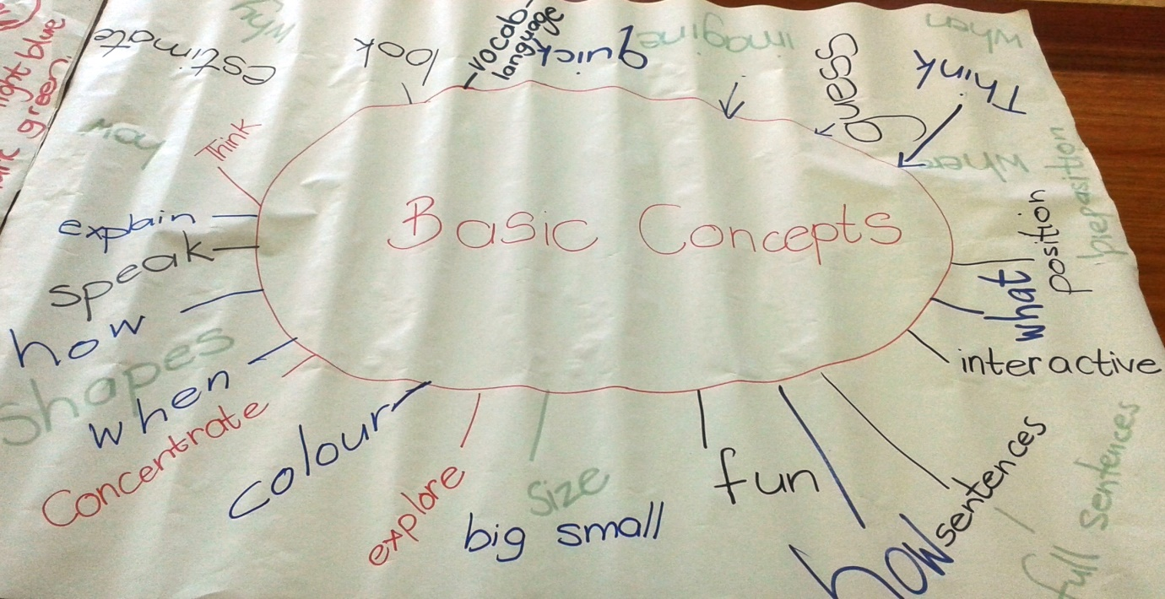
Picture 2:
