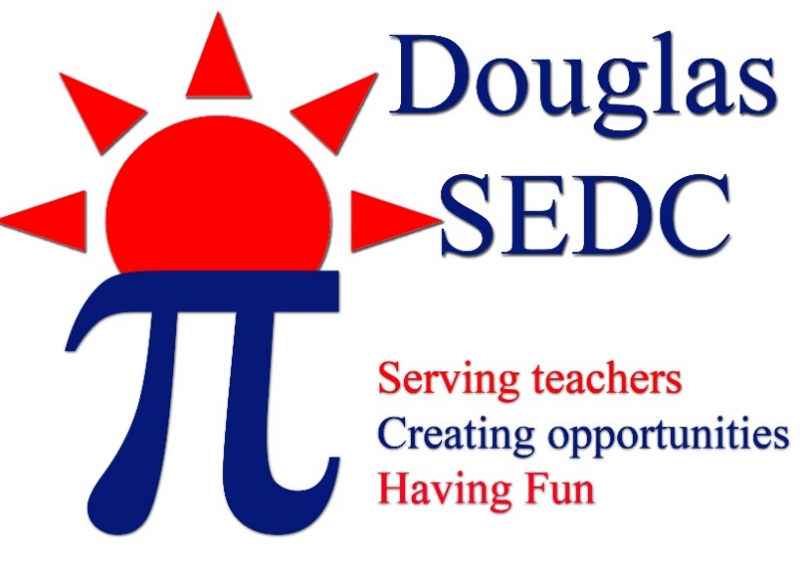

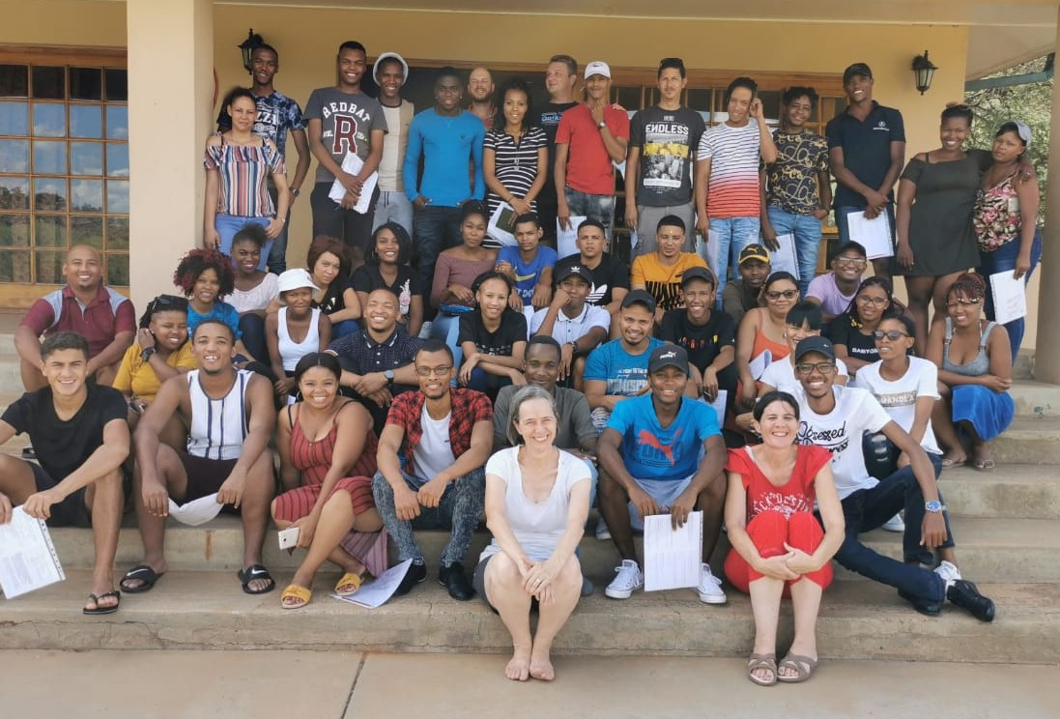
Programme Overview
Douglas SEDC is a NPC that offers Maths and Science support to schools in the Douglas, Prieska, De Aar, Phillipstown and Britstown areas. Our unique model employs a team of 50 teacher assistants all of whom are expected to study a correspondence course of their choice while working with us. In this way we up-skill our local youth while they serve the children in our community.
Our most important goal as an organisation is to increase the number of financially independent adults in the rural Northern Cape. The project has been running for six years in Douglas, three years in Prieska and two years in De Aar, Phillipstown and Britstown. We are now getting to a point where we are starting to put qualified adults back into our community. Almost all of our team are first generation students who are changing the financial trajectory of their families. To date we have six of our ex teacher assistants working full time as teachers at various schools in the Northern Cape and there will be a few more added to this number each year.
By improving the maths skills of scholars we increase access to tertiary studies and thus also increase the chances of our learners becoming financially independent adults.

Our community programme has three components:
- An In-schools maths programme serving approximately 9600 learners per week.
- An After-schools maths programme serving approximately 400 learners per week
- An In-schools reading support programme for grade 3 and 4 learners for approximately 1300 learners per week.(Douglas only)
Our in schools maths and reading programmes offer a small group half hour intervention per week. Activities focus on core concepts and we try to create a fun approach to learning. The learners look forward to our visits each week. Our afternoon programme offers a weekly, voluntary 2 hour extra maths lesson to gr 7 – 12 learners. Here we focus on improving skills that will improve their maths marks. We find that teaching in class is happening faster than learners are able to keep up with. Our afternoon sessions offer learners an opportunity of practising what they have learnt in class. Shyer learners feel more confident asking questions in our small groups than they do in class.
In addition we hold regular ‘special events’ every year. This typically includes maths competitions, maths camps, parent workshops, teacher workshops and participation in the Eskom Expo Competition for young scientists. Our team of 60 often has “progros” where we invest time and money into their leadership development.
We recognise that Early Childhood Development is critical and we are in process of applying for funding to include a weekly parent with pre-schooler programme which will equip parents in stimulating their children’s academic growth and give children access to the toy library that they do not have at home.
Every week we ask teachers to give us feedback on the activity offered to their class that week. We offer a satisfaction scale of 1 – 4 and aim for an 85+% top-box tick. We achieve this regularly as the table below attests.
Quality Returns DSEDC 2019 Percentage “Top Box tick” | 2019 T1 | 2019 T2 | 2019 T3 | 2019 T4
Punctuality: The team arrived on time and started their group quickly | 86% | 90% | 92% | 93%
Dress: The team was dressed professionally | 79% | 84% | 86% | 86%
Respect: The team was friendly and respectful to learners and staff | 80% | 90% | 90% | 90%
Discipline: The team displayed good classroom management skills | 76% | 83% | 88% | 90%
AVERAGE TEAM Performance | 80% | 87% | 89% | 90%
The learners had fun OR the worksheet used correct font, language and spacing | 81% | 87% | 89% | 85%
The activity builds good concept OR the ws encourages independent working | 81% | 85% | 88% | 87%
Well oraganised with necessary resources OR Builds good concept or consolidates known work | 79% | 83% | 87% | 86%
Team adjust activity/worksheet to appropriate level of learners. | 79% | 83% | 87% | 85%
AVERAGE ACTIVITY Performance | 80% | 85% | 88% | 86%
Photos
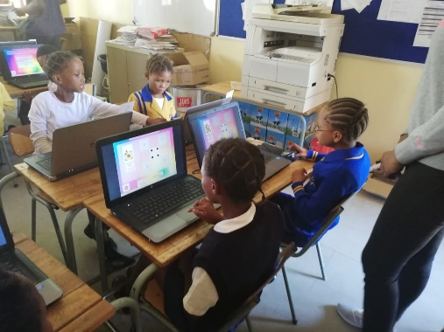
Learners in action on the reading programme

Grade One Parent Workshop

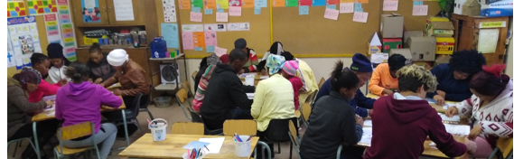

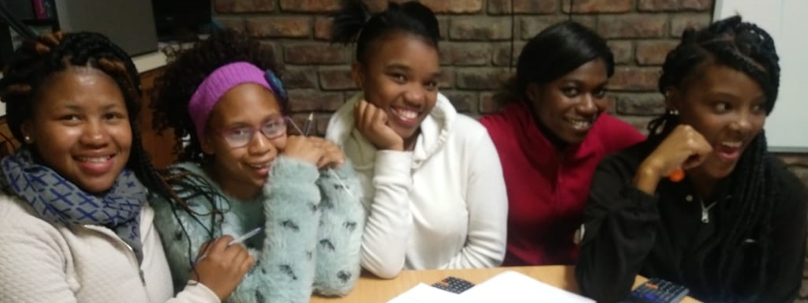
Grade 11 Learners at an Evening Exam Revision Session
Past team members Brumilda Julies and Thembakile Dladla receiving their degrees.

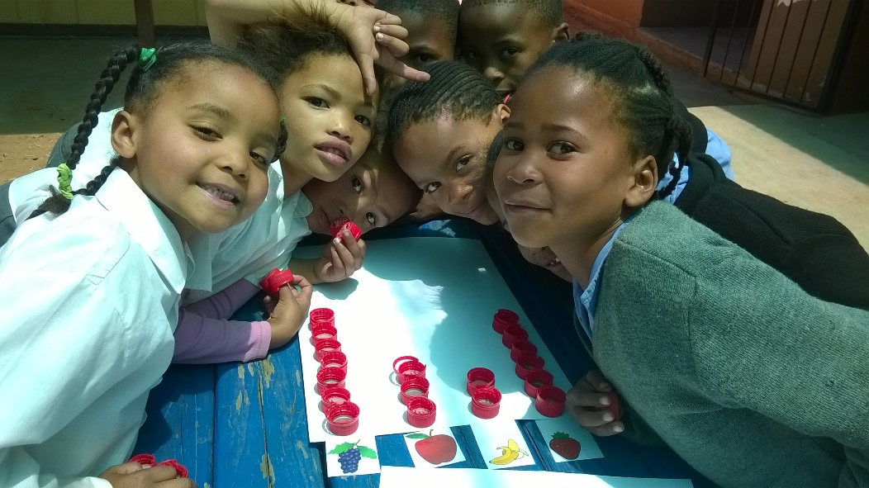
Grade One learners learning about graphs Grade 6 learners having fun with the team
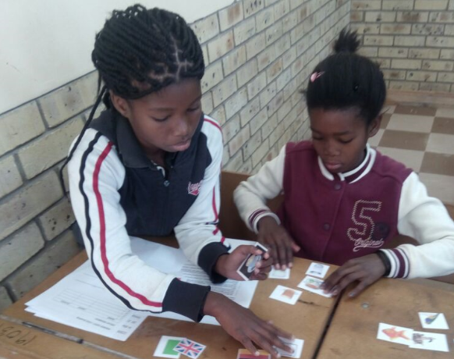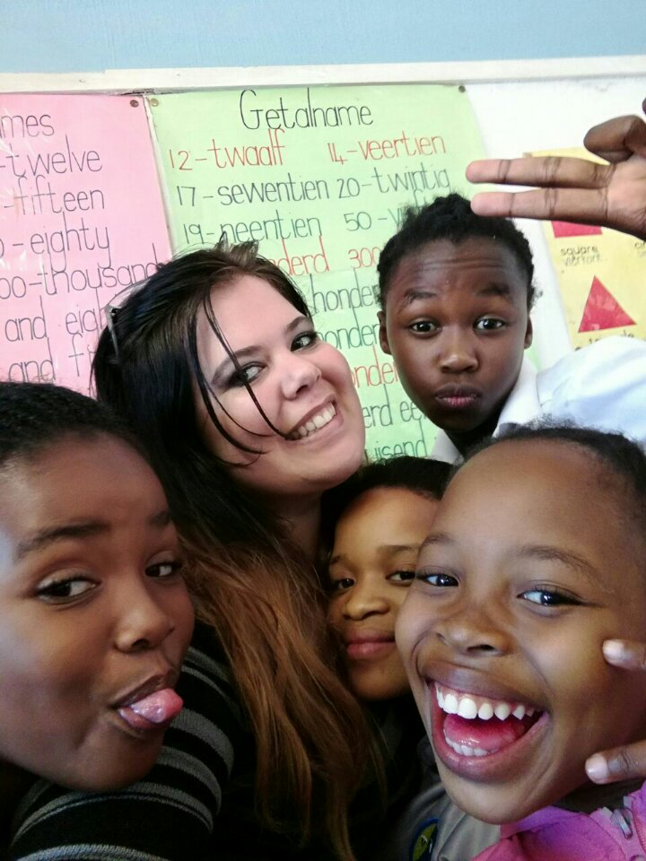
Grade7 Learners solving Einstein’s famous “Who owns the Zebra?” puzzle
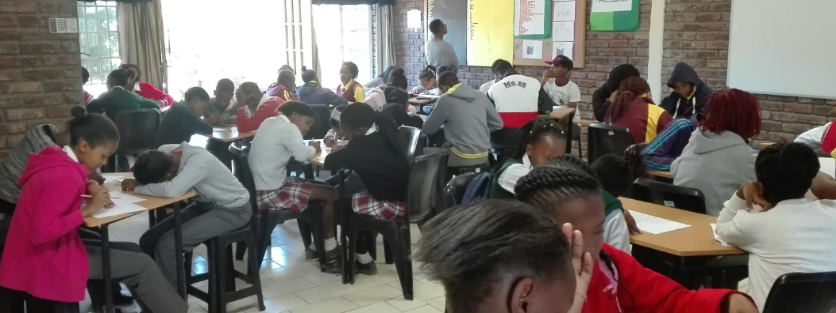
Grade 8 and 9 Maths Competition at our Douglas Resource Centre.

