Centre for Cognitive Enrichment
Feuersteins Instrumental Enrichment: FIE - Basic Level 1
Authorized Trainer: Lilian Lomofsky, Educational Psychologist
Workshop for Teachers, Therapists, Psychologists, Parents, Facilitators
Enhancing thinking and learning for children ages 3 – 9 years;
and older children/adolescents with special needs.
Accelerates cogntive development, develops social competence
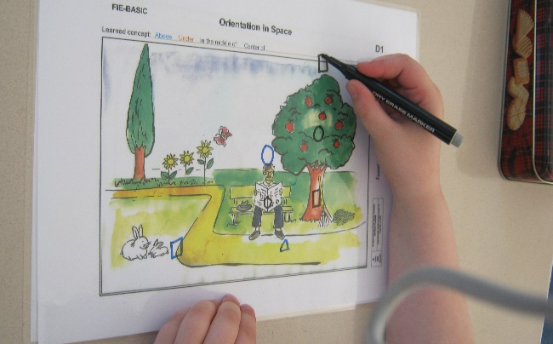
Theory and practice of Mediated Learning Experience (MLE)
Recent Research on neuroplasticity
Modifying cognitive structures and Addressing cognitive functions in all ages
‘Hands on’ experience with 6 FIE Basic Instruments
Principles and concepts for critical and flexible thinking and reasoning are bridged or transferred to class work and daily home and social contexts
- Spatial orientation
- Organization and Planning
- Numerical grouping
- Comparisons
- Identifying Emotions and from Empathy to Action
Date: 10 – 14 January 2022
Time: 8.30 – 16.30 daily
Place: Cape Town
Venue: To be advised
Course Fee: R 9 500 (includes User/Teacher Guide Book and a student set of 6 IE Basic Instruments)
Certificates awarded from the Feuerstein – Bassou Training Academy on completion
Numbers will be limited to enable social distancing and all Co-vid protocols will be observed
RSVP: closing date 18 December 2021
Inquiries: Lilian Lomofsky: Email: LLomofsky@mweb.co.za
Cell: 072 397 9462
Completed form to be returned before the 18 December 2021
Email: LLomofsky@mweb.co.za Cell/sms: 072 397 9462

Name:

Organisation:
Position:
Postal Address:

Postal Code
Telephone: ( …..)
Cell (….)
Email Address:

I will attend the following: Mark with an X

1. Training Workshop: IE Basic Level One ……………….
2. Additional IE Instruments can be ordered for your own account. Price List is available on request ………………………………………
3. If you require CPDs from the HPCSA Reg no: …………………

Fees include a set of Six IE Instruments and Teacher Guide Book.
Tea/Coffee, light refreshments, course notes (Please bring your own lunch).
(5% discount for two people from the same institution & for registered students)

Payment Details:

Payment: Cash ……EFT ……….Amount: …………………

Banking Details Please email or sms proof of banking
Name of Account: Lilian Lomofsky
Standard Bank Claremont Branch Code: 025 109
Savings Account No. 07 748 6080

