BASIC CONCEPTS ADVOCACY PROJECT
PHASE 2: FRANCES BAARD (2020-2021)

REPORT 5
As a result of Covid-19, the scheduled in-person training in Frances Baard district could not proceed, and we rapidly needed to find alternative methods of training. We therefore began to implement an online group-based training and have scheduled a comprehensive online training programme for the year. The 12 training sessions (2 sessions per domain) will be spaced out over the year allowing adequate time for implementation inside the classroom.

- Name of trainers and facilitator/s:
Louis Benjamin (trainer)
Gill Brand (facilitator)
- Date and Time:
Session 9: 12 October, 13h00-14h30
Session 10: 13 October, 13h00-14h30
- Foci of the sessions:
- Reflection on the BCP and the main factors that facilitate or hinder the implementation of the programme
- Main focus was on the conceptual domain of Number
- Register with names, including all officials:
Click here to access the GOOGLE SHEET
- Attendance Statistics:
Session | Date | Present | Apologies | Absent
9 | 12 Oct | 42 (75%) | 0 (0%) | 14 (25%)
10 | 13 Oct | 44 (79%) | 2 (3%) | 10 (18%)
**Number of catch-up views of the recorded session: Session 9 = 27 & Session 10 = 6

- Evaluation of training: 47% of attendees drawn from all of the teacher clusters (#6) responded.
i) Rate the training sessions: -
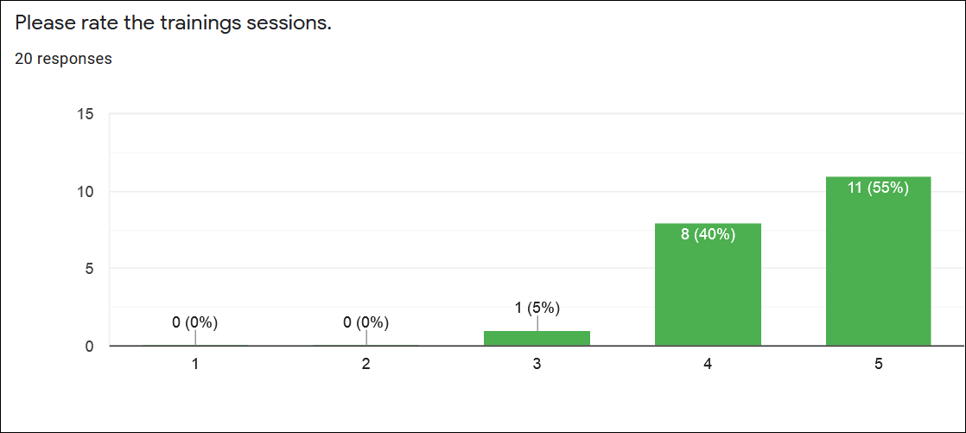

Scale: 1= very poor | 2 = poor | 3 = average | 4= good | 5= excellent

95% of the teachers rated the overall training as either excellent (55%) or good (40%), while one teacher (5%) rated the session as average.

ii) Rate the quality of the information presented: -
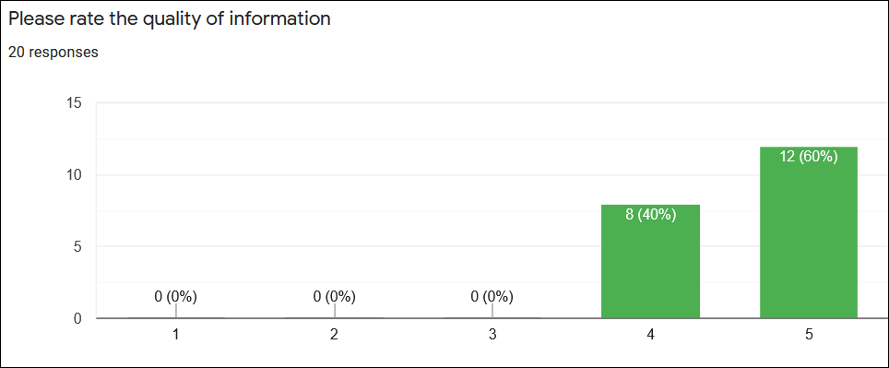
Scale: 1= very poor | 2 = poor | 3 = average | 4= good | 5= excellent

100% of the teachers rated the quality of the information as either excellent (60%) or good (40%).

iii) Rate your interest in the Basic Concepts Programme:-

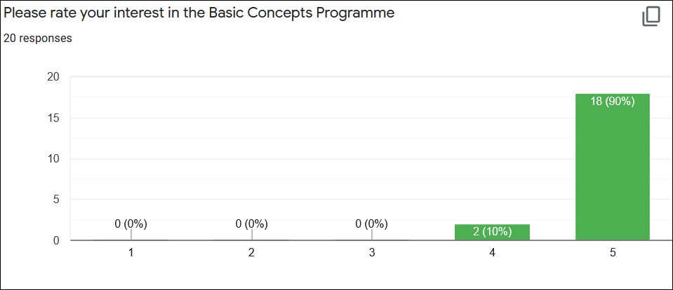
Scale: 1= very low | 2 = low | 3 = average | 4= high | 5= very high

100% of the teachers rated their interest in the Basic Concepts Programme as either very high (90%) or high (10%).

iv) Rate your motivation to implement the BCP in your class: -

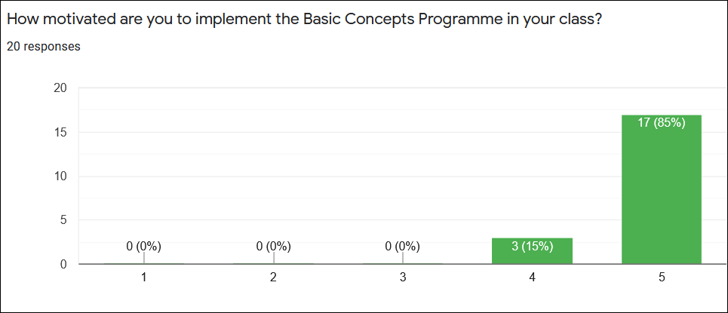
Scale: 1= very low | 2 = low | 3 = average | 4= high | 5= very high

100% of the teachers rated their motivation to implement the BCP as either very high (85%) or high (15%).

v) Rate the quality of your internet connection:-

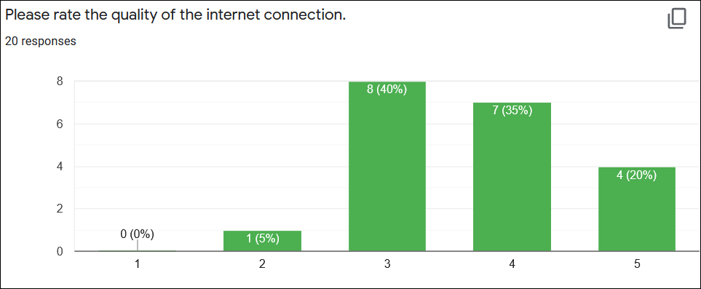
Scale: 1= very poor | 2 = poor | 3 = average | 4= good | 5= excellent

55% rated their internet connection as either good (35%) or excellent (20%), 40% rated their connection as average, while 5% rated their connections as poor.

- General Comments: -
i) The overall feedback from the teachers about the training was highly positive. The following verbatim qualitative comments were made about the current training sessions:-
- I really appreciate every session as it is fruitful and I am motivated to return to class and implement what I've learned. Thank you.
- I enjoy it massively and appreciate it. It was hugely meaningful. Thank you, Louis.
- The training sessions have been very informative.
- The training is very interesting and I learnt a lot. The host is vibrant and includes us.
- I cannot wait to implement in the classroom.
- I will also be using my own initiative to make the lessons more fun and creative…
- The training is very educational and informative.
- Everything conveyed during the session was great and I can't wait to implement it in my classroom with my lovely kids.
- I think that the teachers must come together and discus activities… after the training sessions.
ii) The average attendance at both number training sessions was good (77%). In addition, we also had 33 views of the recorded sessions. This would bring the participation levels at these sessions to over 100%! These were once again very well supported sessions.
iii) The training sessions again focussed on a new conceptual domain for this group of project teachers. This is the 5th conceptual domain to be introduced; the last conceptual domain is still to be introduced before the end of the year.
iv) The teachers were sent training materials (training notes, A3 laminated small group activities as well as associated workbook templates) before the current training sessions.
v) While the majority (95%) of the participants rated the internet connections as satisfactory, good or excellent, there was 1 teacher (5%) who did seem to experience significant problems. The recordings of the sessions might also be helpful for those who had difficulties with viewing the live session or could not attend for some reason.
vi) The overall levels of interest in the BCP and motivation to implement the programme remain exceptionally high (100%).

- Conclusion
This was both a very successful and well attended training. We were very pleased with the positive feedback received from the teachers. We were also pleased with the participation at the session, where we attempted to involve the teachers as much as possible, even though the sessions were being run virtually. See photos below of teacher activities completed during the sessions:-
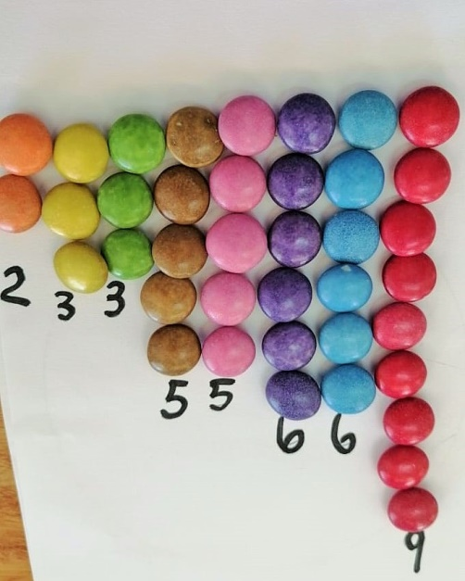
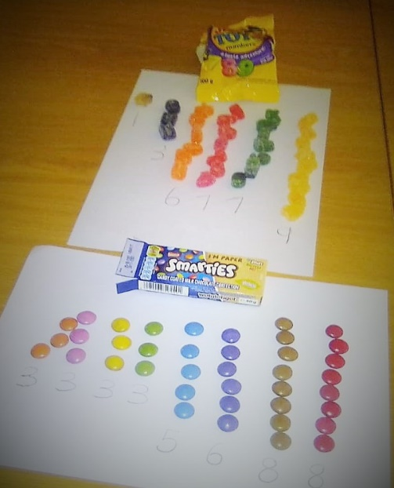

There was a slight decline (9%) in the attendance at the live training sessions since the previous training. We were however pleased with the number of teachers who viewed the recordings of the sessions and particularly of the first session.

The focus will soon shift after next set of training sessions (which are also the last set of sessions) to the mentoring and support of the project teachers inside the classrooms. The Project Leader will in fact be visiting the Northern Cape shortly where he will be invited inside a few of these classes. The main emphasis of the project next year (2022) will therefore also shift to the implementation of the programme with all Grade R learners. The learners who received the BCP intervention in Grade R in 2022 from trained mediators will be tracked and evaluated when they start Grade 1 in 2023.

