nBASIC CONCEPTS ADVOCACY PROJECT
PHASE 1: Pixley Ka Seme & John Taolo Gaetsewe
(2019-2021)
Contact 8: Teacher Interviews (November 2021)

- Name of facilitator/s:
JTG: Louis Benjamin, Gill Brand, Diane Goldsmith, Josephine Takawera
PKS: Louis Benjamin, Gill Brand, Phakama Mahlanyana
- Method & Dates:
Individual telephone calls were made to project teachers at the end of the school year in November. These calls were on average 20 minutes in duration.
- General purpose of the teacher discussions:
To make individual contact with as many of the project teachers as possible to evaluate the implementation of the programme over the year and also to gauge the level of interest to continue with the programme in the future.
- Interview Schedule:
Click here for a link to the interview schedule.
- Registers with names including all officials:
Click here to access the GOOGLE SHEET for JTG
Click here to access the GOOGLE SHEET for PKS
- Interview Statistics:
PKS Clusters | Number of teachers | Number of teachers contacted | Number of teachers not contacted
1 | 9 | 7 | 2
2 | 12 | 9 | 3
3 | 10 | 8 | 2
TOTAL | 31 | 24 (77%) | 7
JTG Clusters | Number of teachers | Number of teachers contacted | Number of teachers not contacted
1 | 10 | 9 | 1
2 | 12 | 11 | 1
3 | 10 | 8 | 2
TOTAL | 32 | 28 (88%) | 4

- Summary of findings from teacher interviews
i) Number of times teachers implement the BCP per week?

Key for legend: 1x per week, 2x per week, 3x per week, 4x per week, 5x per week
The majority (56%) of teachers from both districts implemented the BCP on average five times per week, while 23% implemented it four times a week, 17% implemented it three times per week and 4% implemented it twice per week.

ii) Teachers who implement the BCP in small groups VS big groups:

The majority (88%) of teachers implement the programme with small groups of learners, while 12 % of teachers implement the programme in a big group.

iii) The conceptual domains that were the most thoroughly mediated by teachers:

There was much interteacher variation with respect to the domain they had mediated most thoroughly. The highest proportion (24%) had mediated Colour while 21% had mediated Shape most thoroughly. Smaller numbers had mediated Size (16%), Number (16%) Position (13%) and Letter (10%) most thoroughly.

iv) How prepared are your learners for Grade 1 next year?

Key for legend: 10 point rating scale where one is poor and ten is excellent.

The teachers rated the overall preparedness of their learners for school learning in 2022 on a 10 point rating scale. 73% of the teachers rated their learners as well to very well prepared (a score of 7 to 10) while 27% indicated that their learners were moderately well prepared (scores of 5 to 6) for school learning.

v) Concepts mediated most by teachers: Size, Position, Number & Letter
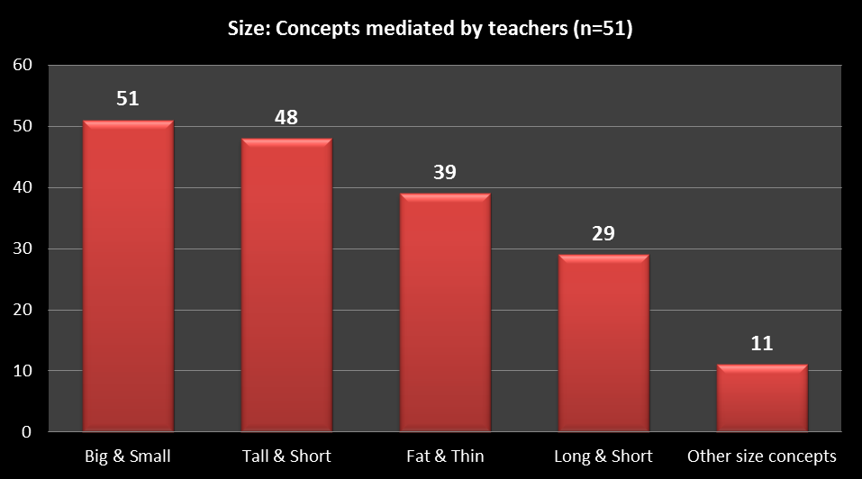

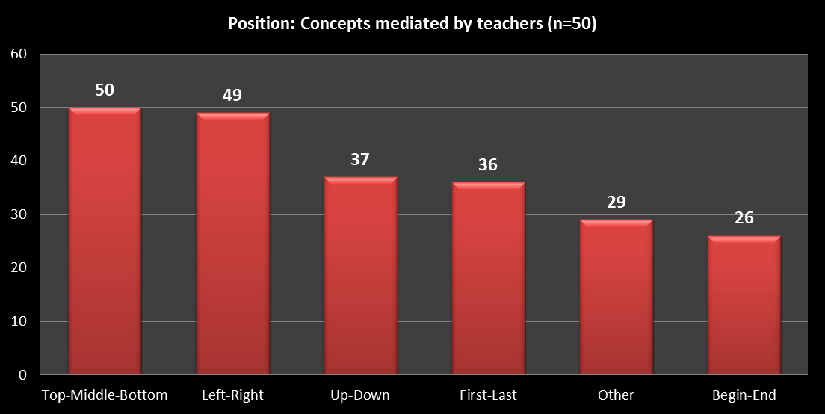

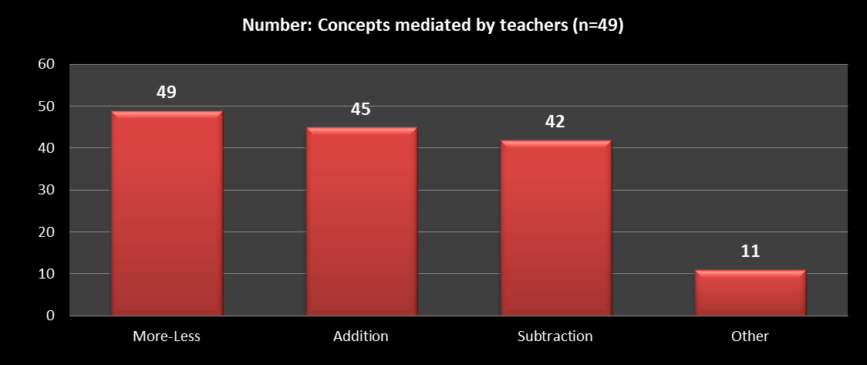

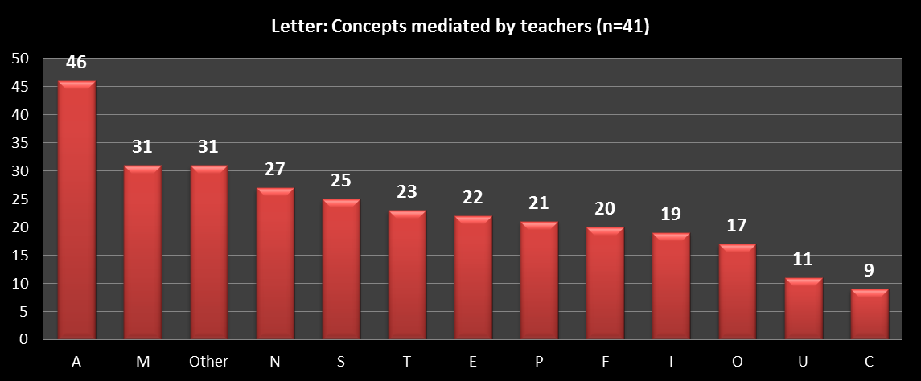

vi) How motivated were teachers to implement the BCP in 2022?

Key for legend: 10 point rating scale where one is poor and ten is excellent.

The teachers rated their motivation to implement the BCP in 2022 on a 10 point rating scale. 85% of the teachers were well to highly motivated to implement the BCP (ratings of 7 to 10), 13% were moderately motivated (ratings of 5 to 6), while 2% were not very motivated (with a rating of 4).

vii) Ratings of the teachers’ level of BCP compliance:

Key for legend: 10 point rating scale where one is poor and ten is excellent.

The interviewers rated the teachers’ overall compliance with implementation of the BCP on a 10 point rating scale. 86% of the teachers were rated as very to highly compliant (with ratings of 7 to 10), while 14% of the teachers were regarded as moderately compliant (ratings of 5 to 6).

viii) Verbatim Responses From Teachers:-
The following themes were drawn from teacher responses:

Theme 1: Use of language inside the classroom
The majority of teachers mentioned language development and language usage inside their classrooms and beyond. This seemed to be the most positive benefit of the programme according to the teachers.

‘Now they have the conceptual language to describe their environment by comparing and differentiating …they are so successful.’
‘They can speak in full sentences and respond in a full sentence. Their vocabulary has definitely improved.’
‘The programme helps to improve their language and vocabulary and to respond to questions and they even challenge me with questions.’
‘ I can give complex instructions and they can follow these instructions. Each child is given a chance and they can all participate.’

Theme 2: The benefits of the BCP for teachers
These teachers made positive comments about the BCP and how it was aiding them in the classroom or had changed their approach to teaching.

‘I am positive about the BCP because it is aligned with CAPS and it is a tool to use inside the classroom.’
‘I have developed as a teacher and I'm able to notice and assist the individual child with their challenges.’
‘It helped me as a teacher because I've learnt to use questions to (elicit) responses from my learners.’
‘I have learnt how to teach the learners and how to keep them focused and interested.
‘I have learned how to help my struggling learners by mediating more … to help them to understand concepts. I have improved a lot as a teacher.’
‘The Basic Concepts Programme has really saved my learners this year.’

Theme 3: The impact of COVID on teaching and learning
These teachers made comments about how COVID had had a direct negative impact on teaching and learning.

‘Absenteeism due to covid influenced the pace of the programme.’
‘Leaners are often absent which is a big problem. My class is divided into 2 groups, so I often had to repeat work. It is very frustrating.’
‘At the beginning of the year it was really tough... I had a number of health issues. I did not run the programme so often then... I was hospitalized with covid and afterwards, I was always tired in class.’
‘The pandemic caused abnormal conditions in the classroom.’

Theme 4: The benefits of the BCP Model for learners
These teachers made comments about the overall benefits of the programme for their learners.

‘The Concept Teaching Model really helps... it also helps the children to understand the concepts and they can respond and they can make up their own stories and it encourages them to speak up.’
‘The learners have become used to the structure and the questions in the sessions.’
‘The learners are really excited about the programme. Their self-esteem has improved and they are socializing more with their peers.’
‘I wish they could just let us teach basic concepts because it allows a child to think and use his or her mind.’

- Summary
The BC Facilitators ran individual teacher interviews and spent approximately 20 minutes per teacher on the phone. We were able to speak to the majority (83%) of teachers in both districts. The overall findings from these interviews were very positive. The Facilitators accordingly rated most (86%) of the teachers interviewed as either very compliant or highly compliant with the programme. The findings seemed to concur with the teachers’ responses during the telephone interviews.
The Project Facilitators were impressed with the overall responses from the teachers, however, we were particularly pleased to hear that 79% of the teachers had been implementing the BCP 4 or 5 times per week. It should however be noted that a majority of the teachers were using a rotational teaching design as only half their learners were at school every day. The teachers placed most of their attention on the following four conceptual domains: colour, shape, size and number while they gave the least attention to position and letter (which are usually implemented towards the end of the year).
The project teachers seemed to have internalized the BCP model and were positively disposed towards it. 85% of the project teachers indicated that they were very motivated to continue implementing the programme in the future. Many of the teachers indicated that they would be interested in helping the Project Facilitators to induct new teachers into the project.
All teachers evaluated their learners to be prepared for learning in Grade 1 in 2022 (73% very well prepared and 27% moderately prepared). The project learners will be independently evaluated at the start of the year to determine their overall level of school preparedness.
In conclusion, the project teachers seemed to have benefited enormously over the past three years and gained much experience implementing the BCP with three cohorts of learners, notwithstanding the impact of the COVID pandemic. We found most teachers receptive and willing to share their experiences with the interviewers. This was with the exception of a a small group of 11 teachers. We are confident that the majority of the project teachers will continue to implement the BCP in the future.

