BASIC CONCEPTS ADVOCACY PROJECT
PHASE 1: Pixley Ka Seme & John Taolo Gaetsewe
(2019-2021)

Cluster Meeting 2 (April 2021)

- Name of facilitator/s:
JTG: Louis Benjamin, Gill Brand, Josephine Takawira
PKS: Diane Goldsmith, Michele Lothian
- Dates:
13 April: Cluster 1
14 April: *Cluster 2
15 April: Cluster 3
*JTG Cluster 2 was rescheduled to the 21 April
** All cluster meetings were 45-60minutes in duration
- General purpose of the sessions:
To support and assist teachers with the implementation and pacing of the BCP in their classes as well as to provide focussed input on the conceptual domain currently being implemented in the classes.
- Current Conceptual Domain:
Conceptual Domain of Shape

- Registers with names including all officials:
Click here to access the GOOGLE SHEET for JTG
Click here to access the GOOGLE SHEET for PKS
- Attendance Statistics:
PKS Clusters | Date | Present | Apologies | Absent | Connection Problems
1 | 13 April | 2 (20%) | 3 (30%) | 1 (10%) | 4 (40%)
2 | 14 April | 4 (31%) | 0 | 1 (7%) | 8 (62%)
3 | 15 April | 6 (60%) | 2(20%) | 2 (20%) | 0
TOTAL |  | 12 (36%) | 5 (15%) | 4 (12%) | 12 (36%)
*The district official was present at one of the three cluster sessions.
JTG Cluster | Date | Present | Apologies | Absent | Connection Problems
1 | 13 April | 9 (90%) | 1 (10%) | 0 | 0
2 | 14/21 April | 6 (46%) | 1 (8%) | 6 (46%) | 0
3 | 15 April | 0 (%) | 3 (33%) | 1 (11%) | 5 (56%)
TOTAL |  | 15 (46%) | 5 (16%) | 7 (22%) | 5 (16%)
*Both of the district officials were present at all three cluster sessions.

- General Comments:
i) The teachers in each district were divided into three clusters with 9-13 teachers per cluster. The groupings were mainly formed because of their proximity to a physical venue or school in the area. There is however one cluster in each district that has no physical venue and only meets virtually.
ii) The number of teachers in each district has contracted from 85 to 65 since last year. This drop in teacher numbers can mainly be attributed to resignations and the fact that many teachers were not reappointed to their positions.
iii) It was the responsibility of the lead teachers in each of the clusters to host the meetings as well as to facilitate the connectivity of the teachers at the venue. Most teachers were supported by a more experienced IT person at their schools.
iv) Attendance at the cluster sessions proved to be more problematic than at the first round of sessions. There was a drop of 20% in attendance; however, we found that 26% of the teachers had struggled to connect during part of or the entire session. The level of absenteeism was the same (17%) for the last two rounds of cluster sessions.
v) The teachers have been able to access recordings of the cluster meeting sessions if they were not able to attend the sessions themselves.

- Feedback from Cluster Sessions:
i) The overall feedback from both districts indicates that the majority of teachers have continued to implement the BCP inside their classes. This has also been supported by the visual evidence of implementation that has been posted regularly on the WhatsApp groups (see photos below).
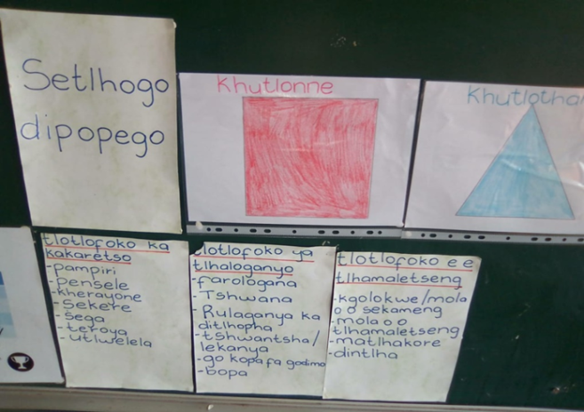
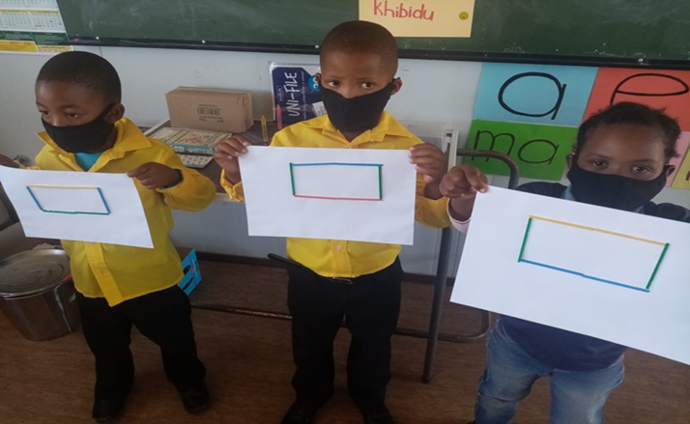

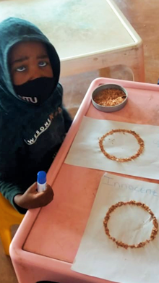
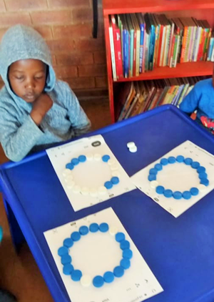

ii) It was difficult to determine the rate of implementation since the last set of cluster sessions, however, we were able to determine that most teachers had mediated between 4 – 6 colours and started to implement shape and will continue with this domain for the next 6-8 weeks.
iii) It seemed that the teachers remained moderately-to-highly motivated to implement the programme. In a survey conducted after the cluster sessions, 10 teachers (91%) indicated that they were highly motivated to implement the programme, while one teacher (9%) was moderately motivated to implement it.
v) Verbatim comments from the cluster sessions:
‘I love basic concepts because I have gained more information/knowledge and it is integrated with mathematics, home language and life skill. Big-up DOC and thanks for such interested lesson for today.’
‘The BCP program is very helpful as it helps the children to answer questions using the correct language format.’
‘The BCP is very good because it helps my learners to concentrate, speak confidently and to know about things inside the classroom. It also helps me to know how to say things (to my learners) inside the classroom. The BCP also helps me with my university assignments.’

- Conclusion:
While the cluster sessions in both districts were beset with many technical and connectivity issues, we were aware that the teachers remained highly motivated to run the programme inside their classes. The level of challenge experienced during this round of cluster sessions was however of concern to the BC Team. It sometimes took up to half an hour to get the sessions started. Furthermore, it was evident that many teachers could not remain connected for the duration of the session. As a result we could not get the kind of feedback and engagement we had hoped to receive from teachers during this round of cluster sessions. The sessions were therefore mainly content-based (shape refresher). Notwithstanding, the feedback from teachers indicated that they had found the sessions very helpful.

The BC Team has decided to vary its approach for the forthcoming round of cluster sessions in an attempt to connect directly (via cell phone) with all project teachers. It is important that the BC Team remains responsive and flexible and is able to respond potential difficulties to ensure that we can continue to provide the best level of support and encouragement to the project teachers.

