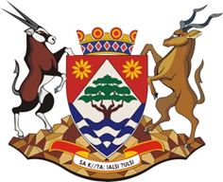

Exploratory Visit to the John Taelo Gaetsewe District, Northern Cape (2018)

Visit Date: 8th November (meetings in the morning) + 9th November (site visits in the morning)
Venue: Kuruman, District Office

PROGRAMME
- Dates for the implementation of the project in 2019
- Core Planning for the project:
  - identification of teachers and schools:
  - logistics for training: numbers (teachers, officials, volunteers) + venue, equipment, travel , food and accommodation
  - follow-up support visits : frequency of visits, travel arrangements, volunteers
  - protocols to gain access to schools/classes and introductory letter
- Other planning aspects: BC Workbooks, Groupings, Placement of BCP in the school day, etc.
- Volunteers:
  - role of volunteers
  - identification and selection of volunteers
- Research:
  - research process and time line
  - selection of the schools (control = 4 and experimental = 10)
- Context issues: What do BCU need to know about the territory – petrol, autobanks, restaurants, accommodation, shops, emergency services, condition of roads, etc.
- Site visits: Visit to the nearest 3 schools, a tour of the town , and to the training venues
- General:

