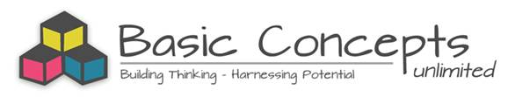

KWENA BASIN PROJECT (2014-2018)
A Basic Concepts Project for Foundation Phase Teachers in Four Schools

Word Test Results: 2014 - 2016

Aim
The project aims to systematically improve the language, cognitive and scholastic functioning of Foundation Phase learners from four multi-grade schools in the Kwena Basin by focusing on the quality of teaching and learning. The Basic Concepts Programme (BCP) is being used as a common approach to develop and extend the prerequisites for learning in English (First Additional Language). The teachers are being trained as mediators of the BCP and are receiving ongoing mentorship and support during the project.

Measurement and Evaluation
A number of measures are being used to evaluate the intervention and the project. Learners’ knowledge of basic conceptual systems is being assessed on an annual basis. The results of the Test of Basic Concepts Knowledge in Grades 1-3 are being compared with the baseline data on an annual basis. The learners’ literacy knowledge is also being assessed on an annual basis in Grades 3 - 4. The results of the Word Test are being compared with the baseline data on an annual basis. The decision was taken to include Grade 4 learners in the evaluation (even though the project is focused on the Foundation Phase) in order to assess the delayed effects of the project. This is particularly important for learners in Grade 4 who are being taught for the first time with English as the language of instruction and learning. The focus of the current report is to compare the data gathered at baseline in 2014 with the data gathered after the first years of intervention (2015, 2016). Data is gathered towards the end of the third term every year.
Test Instrument: Word Test
The Word Test is a literacy test designed to determine the number of words written by learners in 15 minutes. In this project the words are written in English. Children are encouraged to continue writing until the end of the test, but they are not rushed. Spelling errors and words classified as non-sense words are subtracted from the total number of words written during the test. Non-sense words include words that:- i) cannot be decoded, ii) are repeated in the test, and iii) have more than 2 spelling errors. The Word Test is a direct measure of vocabulary development and early word writing skills. It is also reasonable to assume that most words that can be written by a learner could also be read by that learner. The Word Test is based on a similar measure developed by Marie Clay (1985).

Method:
Data was gathered from 3 of the 4 project schools in 2014 and 2015. In 2014 data was gathered from Enkeldoorn, Umthombopholile, and Klipspruit, while in 2015 data was gathered from Enkeldoorn, Umthombopholile and Phakama. In 2016 data was gathered from all 4 project schools. It is therefore likely that the data will not be entirely comparable particularly when matching the average scores in a grade. Comparative data was gathered from a school in a socio-economically deprived area of Cape Town.

Total number of learners assessed at the project schools (2014-2016)
 | Grade 3 | Grade 4
2014 | 28 | 28
2015 | 41 | 45
2016 | 69 | 62
Total | 138 | 135

Results:
Grade 3
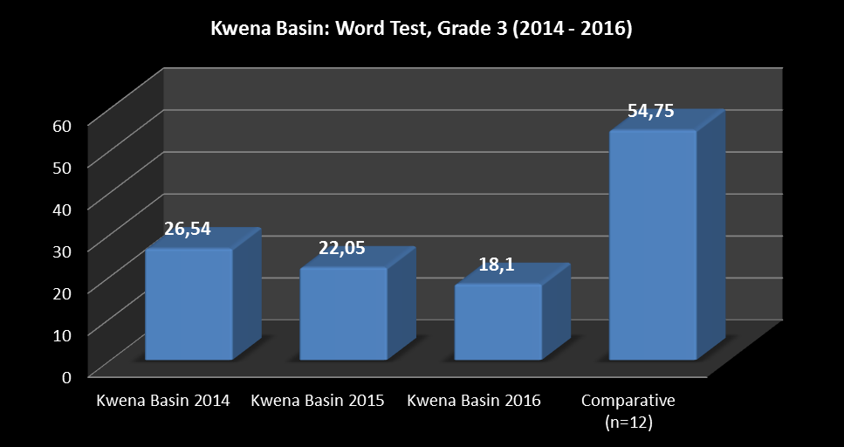
There has been a decline (8.44 points) in the average score since the baseline assessment in 2014. The decline in the average scores corresponds with a delay of approximately 6.3 months compared to the baseline learners at the start of the project. The project learners were approximately 2.3 years delayed compared to the control learners.
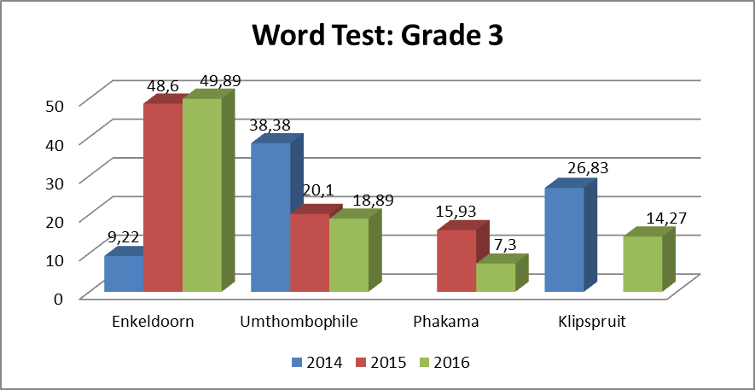

While there were impressive gains in the average score at one of the project schools since the start of the project (Enkeldoorn: +40.67), there were significant declines at two schools (Umthombophile: -19.99 and Klipspruit: -12.56). (*Note: No baseline data was gathered from Phakama, however there has been a decline of -8.63 points since 2015.) There seems to have been some stability in the results over the last two years at Enkeldoorn and Umthombophile, while there has been a relatively large decline at Phakama over the same period. There was a big difference (36.4) between the average scores at the highest scoring school (Enkeldoorn) and the other schools in 2016. This equates to a difference of approximately 2.3 years. The learners at Enkeldoorn were in fact functioning slightly below the average score (-4.86) expected of a child in Grade 3. See the Figure above.

Grade 4
There has been an increase (11.13 points) in the average score since the baseline assessment in 2014. The increase in the average scores could be regarded as a word gain of approximately 7 months compared to the baseline learners at the start of the project. The project learners were still approximately 19 months delayed compared to the control learners.
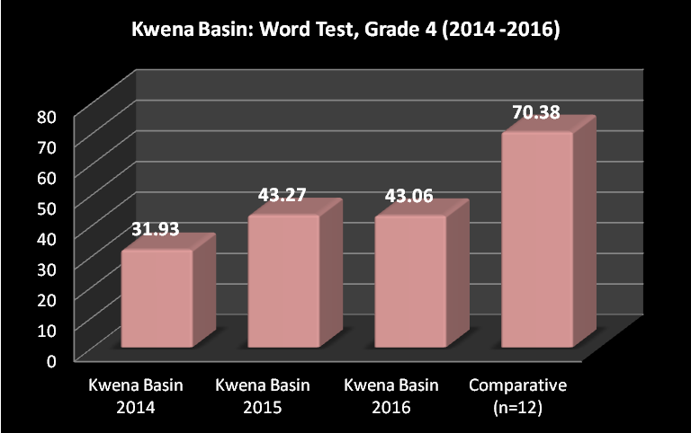

While there were gains in the average scores at two of the project schools since the start of the project (Enkeldoorn: +53.58 and Klipspruit: +5.08), there was a small decline in the scores at Umthombophile (-0.3). (*Note: No baseline data was gathered from Phakama, however there has been an increase of +5.09 points since 2015.) There was also a general increase in the scores at the project schools since 2015. (This does not include Klipspruit as data could not be collected there in 2015). There was a big large difference (36.47) between the average scores at the highest scoring school (Enkeldoorn) and the other schools in 2016. This equates to a difference of approximately 2.3years. The learners at Enkeldoorn were in fact functioning slightly above the average score (+6.82) expected of a child in Grade 4. See the Figure below.
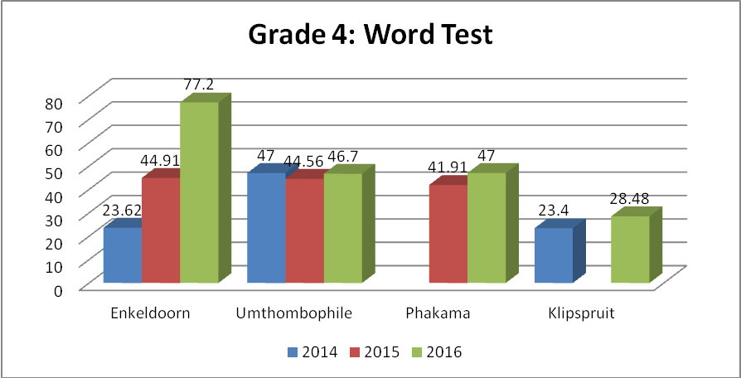
Discussion:
While there has been an improvement in the results of the Grade 4 learners since the start of the project in 2014, there has also been a decline in the results of the learners in Grade 3. The improvement of the Grade 4 learners translates into an average 7 months gain in word knowledge, while the decline of the Grade 3 learners translates into a 6 month delay in word knowledge at the project schools. The learners at the project schools in Grade 4 have thus narrowed the gap with the comparison learners to 19 months, while the Grade 3 learners have widened the gap with the comparison learners to 27 months.
The Grade 3 results show a decline in the average score year on year (2104-2015: -4.49 & 2015-2016: -3.95) since the start of the project. There were significant declines in the scores at three of the schools; however significant gains have been made at one school since the start of the project. The decline in the average scores is of concern. It is difficult to determine at this stage what the possible causes for this might be. It could be that the gains in word score is a cumulative process and these learners have also not yet started to receive instruction in English, which happens in Grade 4. The situation at Enkeldoorn is different in that the project teacher is from Zimbabwe and as such communicates with her learners mainly in English.
Even though the average results for the Grade 4 learners have improved since the start of the project, they did show a small decline (-0.21) from 2015 to 2016. This decline was most likely because of missing data from one of the project schools (Klipspruit) in 2015. The score of the Grade 4 learners at Klipspruit in 2016 was 14.58 points lower than the average (43.06) score in Grade 4. There was in fact an improvement at 3 schools from 2015 to 2016 and at Klipspruit there was an improvement from 2014 to 2016 (no data was available in 2015). Overall therefore, the results suggest a consolidation of the gains since the start of the project and this might also point to the developing language understandings from previous grades.
In conclusion, while the overall gains in the word scores in Grade 4 are very pleasing, the declines in the scores in Grade 3 are concerning and warrant further examination. The three schools that showed the largest declines should be asked to provide some of their own understandings of these worrying results. On a more encouraging note I would like to acknowledge the remarkable gains made by the smallest school in the project, Enkeldoorn, in Grade 3 and 4 during the project.

______________________________________________

