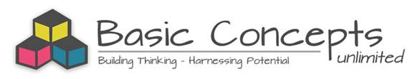

KWENA BASIN PROJECT (2014-2018)
A Basic Concepts Project for Foundation Phase Teachers in Four Schools

Test of Basic Concepts Knowledge (TBCK)
Intervention Data: Year 4 (2018)

Aim
The project aims to systematically improve the language, cognitive and scholastic functioning of Foundation Phase learners from four multi-grade schools in the Kwena Basin by focusing on the quality of teaching and learning. The Basic Concepts Programme (BCP) is being used as a common approach to develop and extend the prerequisites for learning in English (First Additional Language). The teachers are being trained as mediators of the BCP and are receiving ongoing mentorship and support during the project.

Measurement and Evaluation
Two measures are being used to evaluate the project, namely the Test of Basic Concepts Knowledge (TBCK) and the Word Test (WT). The current report will focus on the results of the TBCK following the third year of intervention.

Learners’ knowledge of basic conceptual systems has been assessed on an annual basis. The results of the Test of Basic Concepts Knowledge in Grades 1-3 after four years of intervention (2015-2018) are being compared with the baseline data of 2014. The data is gathered annually at the end of the third term (this is when the project started) and these results are used as a proxy for the learners’ results at the beginning of the following school year.

Test Instrument:
The Test of Basic Concepts Knowledge (Benjamin, 2005) is a screening test which assesses learners’ knowledge of the following 6 conceptual systems:- colour, shape, size, position, number and letter. It was designed to assess learners’ preparedness for formal school learning in Grade 1 at the start of the year. Some validity data on the test has found it to be a predictor of scholastic performance for Grade 1 learners (Benjamin, 2009a, 2009b, 2011, 2016). The test has thus far mainly been used to test learners in their mother tongue. This should be borne in mind when interpreting results for these learners as instruction and testing are being done in English, their first additional language.

The test battery consists of a simple paper and pencil format with a limited number of items per conceptual system ranging from 3 (size) to 5 (position) items with a total of 24 items. Each item is scored as correct (1) or incorrect (0). 3rd and 4th year students from the Wits School of Education have assisted with the administration of the test. The test is being administered using the individual format. The time taken to administer the test may vary as there are no time restrictions, but on average it is about 30 minutes.

The interpretation of test scores:
0 – 10: Very poor
11-17: Weak
18 -20: Average
20 -24: Strong to very strong

Results:
The test results below reflect the data for 4 project schools: Phakama Primary, Klipspruit Combined, Enkeldoorn Primary and Umthombophile Primary. The test results of 2018, 2017, 2016 and 2015 (Intervention Data for Year 4, Year 3, Year 2 and Year 1 respectively) will be compared to the baseline data of 2014.
Note: Two of the multi-grade teachers (Grade 2+3) from Phakama and Umthombophile resigned from their posts in 2017 and were replaced by two new and not yet fully trained BCP educators. The learners in these classes make up 32% of the learner population in the project.

Grade 1
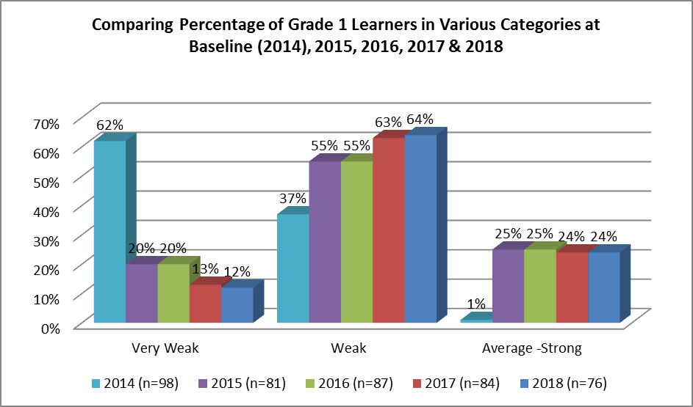
While only one learner (1%) was functioning at the level expected at the start of Grade 1 in 2014, 24% of the learners were found to be functioning at this level after intervention in 2018. In 2014 the majority (62%) of learners were in the Very Weak category, while in 2018 only 12% of the intervention learners were in this group. There has been a 50% reduction in the number of learners in this category and an 8% reduction since 2016/2015. There has been an associated increase in the percentage of learners in the Weak category from 37% to 64%. There has been an overall improvement in average results since the start of the project: 9.47 (39%) in 2014, 14.22 (59%) in 2015, 14.39 (60%) in 2016, 14.29 (60%) in 2017 and 14.79 (62%) in 2018. There has thus been a 56% increase in the average score on this test since the start of the project.

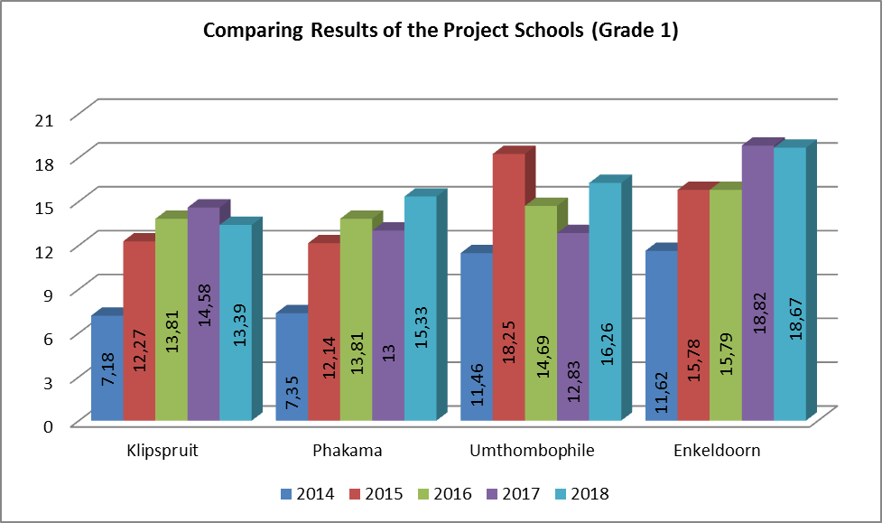
The highest average score in 2018 was attained by learners from Enkeldoorn (18.67). This was the only school where the majority of the learners were found to be functioning in the Average (school ready) range. Lower scores were found at Umthombophile (16.26), Phakama (15.33) and Klipspruit (13.39). The learners at these schools were on average found to be functioning in the Weak range on this test. While there were gains from 2017- 2018 at two of the project schools (Umthombophile +3.43 and Phakama +2.33), there were declines at two schools (Klipspruit -1.19 and Enkeldoorn -0.15). The schools have all experienced gains in their average scores since the start of the project: Phakama +7.98 (108%); Klipspruit +6.21 (86%); Enkeldoorn +7.05 (61%) and Umthombophile +4.8 (42%).

Grade 2
9% of the learners were functioning at the level expected at the start of Grade 1 in 2014, while 49,5% were found to be functioning at this level in 2018. Since baseline there has been a 40,5% increase in the number of learners in the Average – Strong category as well as a 32% reduction in the number of Very Weak learners. The percentage of learners in the Weak category has remained relatively consistent since the start of the intervention process in 2015 (51%, 51%, 34% & 49,5) as the Very Weak learners have moved into this category. There has been an incremental improvement in the average overall results since the start of the project: 11.96 (50%) in 2014, 15.35 (64%) in 2015, 16.28 (68%) in 2016 and 17.73 (74%) in 2017, and 17.45 (73%) in 2018. There has thus been a 46% increase in the average score on this test since the start of the project.
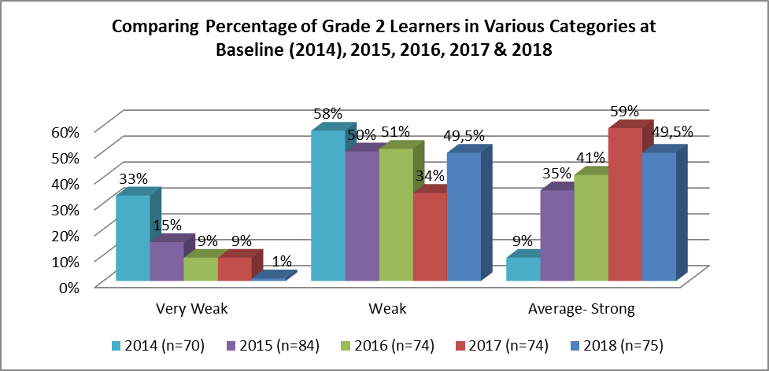
See chart below.
The highest average score (21.36) was attained by learners from Enkeldoorn and was in the Strong range for this test. (This was the highest average score attained on this test since the start of the project.) One of the schools was functioning in the Average range (18.48 for Klipspruit), while two other schools were functioning in the Weak range (14.36 for Phakama and 16.26 for Umthombophile). While there were gains from 2017 - 2018 at two project schools (Klipspruit +0.68 and Enkeldoorn +1.54), there were declines at the other two schools (Phakama -2.27 and Umthombophile -0.39). The schools have all experienced gains in their average scores since the start of the project: Phakama +5.42 (60%); Klipspruit +5.62 (44%); Umthombophile +4.32 (36%); and Enkeldoorn +4.22 (25%).
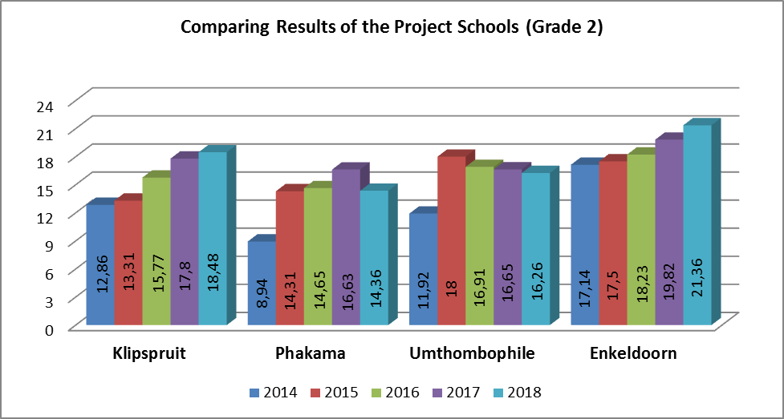

Grade 3
Two-thirds of the learners (68%) were functioning at the level expected in 2017/2018, while only 17% of the learners were found to be functioning at this level in 2014. Thus 51% more learners were in the Average – Strong category on this test compared with the start of the project. The biggest improvement (61%) has been the reduction of learners in the Very Weak category, with a resultant 16% increase in the number of learners in the Weak category since the start of the project. There were no learners in the Very Weak category in 2017/2018. There has been an incremental improvement in the average overall results since the start of the project: 14.42 (60%) in 2014, 16.64 (69%) in 2015, 18.18 (76%) in 2016, 18.74 (78%) in 2017 and 19.00 (79%) in 2018. There has thus been a 32% increase in the average score on this test since the start of the project.
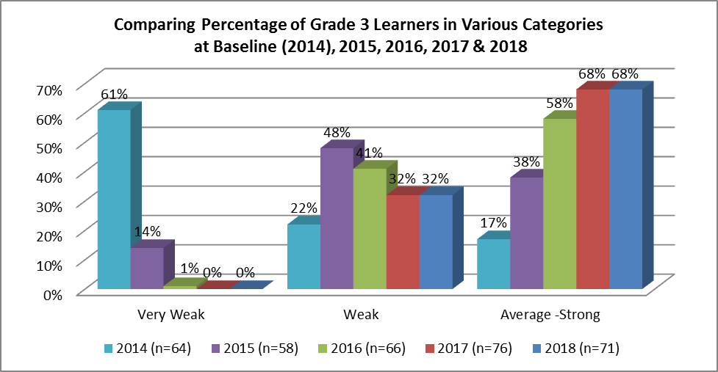
See chart below.
The highest average scores (20.67, 20.17 & 18.29) were attained by learners from Enkeldoorn, Umthombophile and Klipspruit respectively. These learners were on average found to be functioning in the Average - Strong category. The lowest average score (17.59) was for learners at Phakama who were marginally (-0.41) below the average. Small gains from 2017- 2018 were found at two of the four project schools: - Phakama +0.48 and Umthombophile +0.9. There were nominal declines in 2018 at two of the schools:- Klipspruit -0.1 and Enkeldoorn -0.02. The schools have all experienced gains in their average scores since the start of the project: Umthombophile +6.97 (53%); Enkeldoorn +4.84 (31%); Phakama +3.43 (24%) and Klipspruit +2.96 (19%).
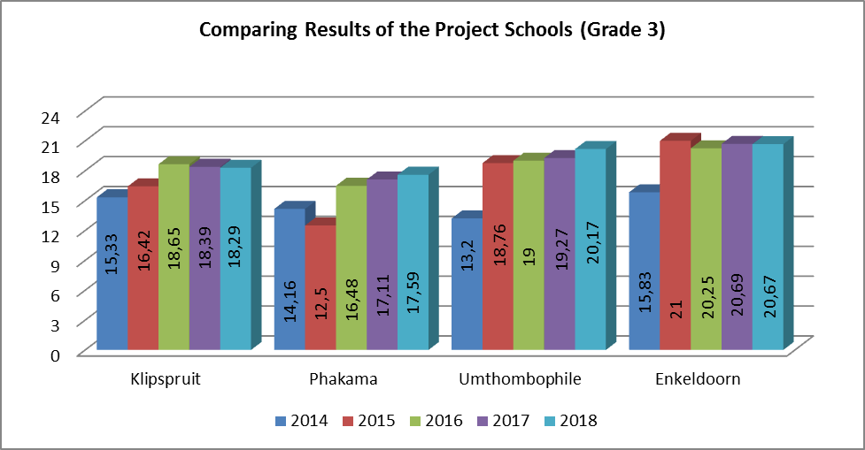

Summary:
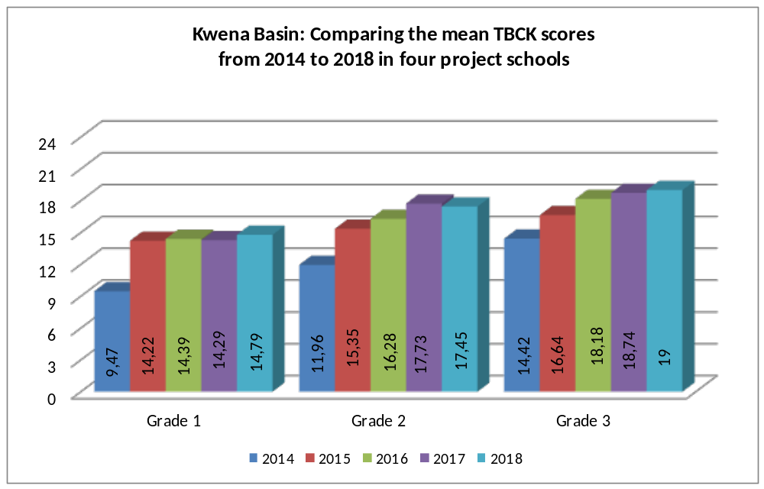
The overall trajectory of the test results remains positive, there has been on average a 43% (5.13 points) improvement in scores since the start of the project in 2014. There have generally been year on year improvements in the average scores since the start of the project. This is with the exception of the Grade 2s in 2018. There has also been a corresponding increase in the percentage (from 8% to 45%) of learners in the project who are regarded as school ready since the start of the project.

While the Grade 3 learners are on average functioning on the required level for this test, the Grade 2 and Grade 1 learners have not yet attained this level. The Grade 2 learners however require only 0.55 points to reach this point, while the Grade 1 learners require another 3.21 points. The Grade 1 and Grade 2 leaners have however made greater gains (56% and 46% respectively) from baseline scores compared with the Grade 3 learners who have made gains of 32%.

The following aspects of the Grade 1 to 3 results were particularly noteworthy:-
- There has been a significant decline (42%, 17%, 11%, 7% and 4% respectively) in the number of learners in the Very Weak category since the baseline data was gathered in 2014.
- There has been a significant increase (8%, 33%, 40%, 50%, 45% respectively) in the number of learners in the Average - Strong category since the baseline data was gathered in 2014.
- The average overall score of the Grade 1s has improved by 56%, the Grade 2s by 46% and the Grade 3s by 32%, since the start of the project.
- The majority (68%) of the Grade 3 learners were functioning at the required level. There were no Grade 3 learners in the Very Weak category – this was the second time that there have been no learners in this category.
- In 2018, the largest declines in results were found at Klipspruit in Grade 1 and at Phakama in Grade 2 (-1.19 & -2.27 respectively), while the largest increases in results were found in Grade 1 at Phakama and Umthombophile (+2.33 & +3.43 respectively) and in Grade 2 at Enkeldoorn (+1.54).
- The lowest average test scores in 2018 were found at Phakama (Grade 2: 14.36 & Grade 3: 17.59) and Klipspruit (Grade 1: 13.39), while the highest average test scores were consistently found at Enkeldoorn (Grade 1: 18.67; Grade 2: 21.36 and Grade 3: 20.67).
- Klipspruit and Enkeldoorn were found to have the most consistent year on year improvements in results since the baseline data was gathered in 2014.

The performance of the learners from the Kwena Basin schools, with the exception of two Grade 1 classes, appeared to have plateaued and stabilized. In 2018 there have been modest improvements in 6 out of 12 classes (+2.22 points) and some declines in the other 6 classes (-2.66). While the greatest improvement in a sub-test score was for shape (+14%), the greatest decline was for size (-19%). It is possible however that the decline in the size scores was due to the administration of this sub-test. It was evident that the students who administered the test had not in all cases asked the learners to draw three objects that were the same. In contrast, in 2017 learners attained the second highest score (88%) on this size sub-test. We therefore contend that the administration of the test might have negatively influenced the results to some (-2.4 points) extent.

It is evident that it has become more difficult to improve on the TBCK scores; that is with the exception of a few classes that still have much room for improvement. For example, there were reasonably significant improvements in two Grade 1 classes this year. However, it might be that if the BCP were implemented more consistently throughout the year, it would assist the learners to make further and all round improvements in their knowledge of basic conceptual systems.

_______________________________________________

