Test of Basic Concept Knowledge:
Results for Control and Intervention Learners

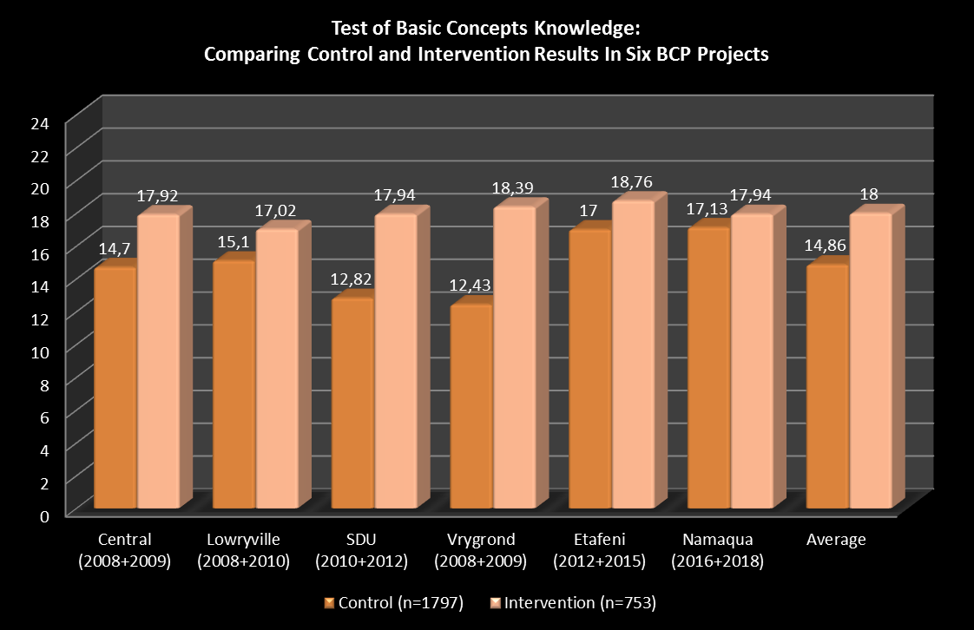
- The results indicate that the majority of learners who received intervention in Grade R were school ready when they started Grade 1, while those who did not were not school ready.
- The total mean score for learners who received intervention was 18.00 (in the average range), while control/non-intervention learners scored 14.86 (in the weak range).
- The scores of the intervention learners were on average 21% higher than learners in the control group.
- There is a positive correlation between the TBCK at the start of the year in Grade 1 and scholastic scores at the end of the year; that is, average-good TBCK at the start of the year correlate with high scholastic scores at the end of the year. These learners were mostly ready to progress to Grade 2.
- The results therefore suggest that not only does the BCP make a consistent and positive difference to learners from these disadvantaged communities, but there are indications that these differences are maintained and expressed in learning gains one year after the intervention.

