

BC ADVOCACY PROJECT: PHASE 1 (2019-2020)
John Taolo Gaetsewe & Pixley ka Seme Education District

Field Visit 4
05 – 08 November 2019 (JTG) & 11 – 14 November (PKS) 2019

Aim
The main purpose of this visit was to provide a final round of classroom support and mentoring to the project teachers before the end of the year. In addition, there was an attempt to provide the Department of Education officials and volunteers with more nuanced strategies and interventions to assist the teachers to develop in their role as mediators of the BCP.

Overview of Visit
The visits to the two districts were each four days in duration. On the first day of each visit, an advanced training session was held for the volunteers and officials at one of the project schools. This was followed by three days of teacher visits. (See Appendix 1 for the visit programme.)
The teachers had begun with the implementation of the last two conceptual domains (Number and Letter) of the programme at the start of the 4th term. They should thus have been busy with these two domains for approximately 4 weeks prior to the visit.
Follow-up data was also gathered during this visit for a pilot research study using the LENA (Language Environment Analysis) device. The initial baseline data had been collected during the second visit to the project in May 2019.

1. Training Sessions for Volunteers and Officials

Training Statistics-
Attendance | John Taolo Gaestewe (JTG) | Pixley ka Seme (PKS)
Number of volunteers | 2 out of 2 | 3 out of 3
Number of local district officials | 2 out of 2 | 1 out of 1
Number of provincial officials and other district officials | 5 | 1
Number of other attendees | *1 | *1
Total | 10 | 6
*Note: Basic Concepts Field Workers from the Western Cape and Mpumalanga attended the training and classroom visits that followed the training.

Comments on attendance statistics –
- All officials and volunteers who were required to be present at the training sessions attended these.
- Two of the provincial officials who attended the training session in JTG did not attend the same training session in PKS, but did accompany us on the class visits that followed the training.

Feedback from the training sessions -
- The training was about 6 hours in duration and consisted of a morning and afternoon session.
- Arrangements for the training were made by the officials in each of the districts. The training was hosted by one of the project schools.
- The participants seemed to find the sessions interesting and particularly the focus on mediational teaching. The sessions also included a revision of the domains of number and letter that were presented during the last visit.
- The sessions included a practical component and an observation of project teachers at the school.
- The participants were also given time to explore their role as mentors of the project teachers as well as ways to enhance their effectiveness with the teachers.
- The training seemed to create a focus for the class visits that were to follow.
- BCU also made use of the training sessions to introduce two of its field workers from other provinces. These field workers might be required to support the project at a later stage.

2. Class Visits and Teacher Mentoring

Visit Statistics-
 | John Taolo Gaestewe (JTG) | Pixley ka Seme (PKS)
Number of schools visited | 13 out of 18 | 12 out of 19
Number of teachers visited | 25 out of 40 | 25 out of 43
Number of officials who were part of the class visits | 7 | 4
Number of volunteers who were part of the class visits | 2 | 3
Number of others who were part of the class visits | 1 | 1

Comments on visit statistics –
- 72% of schools in JTG and 63% of schools in PKS were visited.
- 63% of JTG project teachers and 58% of PKS teachers were visited.
- All officials and volunteers were present for the class visits.
- All scheduled school visits were completed – see programme.

Overview of the school visits-
- The teachers were visited by teams consisting of district and/or provincial officials and/or project team members and/or volunteers. The teams had 2 to 3 members each. These teams left their base towns in Kuruman or De Aar each morning to visit teachers and returned in the afternoons to give feedback at a combined group meeting.
- The purpose of the visits was not to reach all teachers in the districts, but to gain an in-depth and representative understanding of how the programme was being implemented and to gauge the effectiveness of the support teams in the classrooms.
- The support teams also had representatives from Frances Baard and ZF Mgcawu Districts who were being trained for future phases of the project.
- While the visit to the project was during exam time with all the other distractions of the end of the year, we were still able to conduct the visits and class attendance was very good. The school day did however end a little earlier than usual.
- It was evident that a few teachers in both districts were not fully prepared for the visits. It was however difficult to determine whether they were not prepared or were mostly anxious about the visits.
- The support teams placed a great deal of emphasis on making the visits friendly and helpful, even if teachers were not prepared for the visit.
- In our 50 visits to teachers in the districts we found only one teacher who was not implementing the programme at all. There were some teachers (n=5) however, who we suspected were implementing irregularly.
- The vast majority of the observations were of Letter sessions, while a few teachers ran Number sessions. The teachers were given the choice of running demonstration sessions in either domain. (We note that the support teams followed up on Number sessions during our last visit to the project.)
- There was a high level of letter awareness in most of the classes visited and in several classes we were presented with learners who could already read and write sentences.
- While the overall quality of BCs Workbooks was pleasing (particularly in the domain of Letter), we continued to encourage teachers to do more work inside their workbooks.
- The support teams were generally satisfied with the overall physical environment of the classrooms and the use of posters, word walls and of the children’s work on the walls; we were however disappointed with the BCs Theme Tables in some of the classes.
- The teachers’ record-keeping and planning was not flagged as an issue during this visit. This aspect of the visits has been particularly well-tracked and attended to by the classroom visitors and volunteers.
- 4 teachers in each of the districts were acknowledged and rewarded for their consistent implementation of the BCP since our last visit– See the blue coloured reward chart in the picture on the left hand side below.

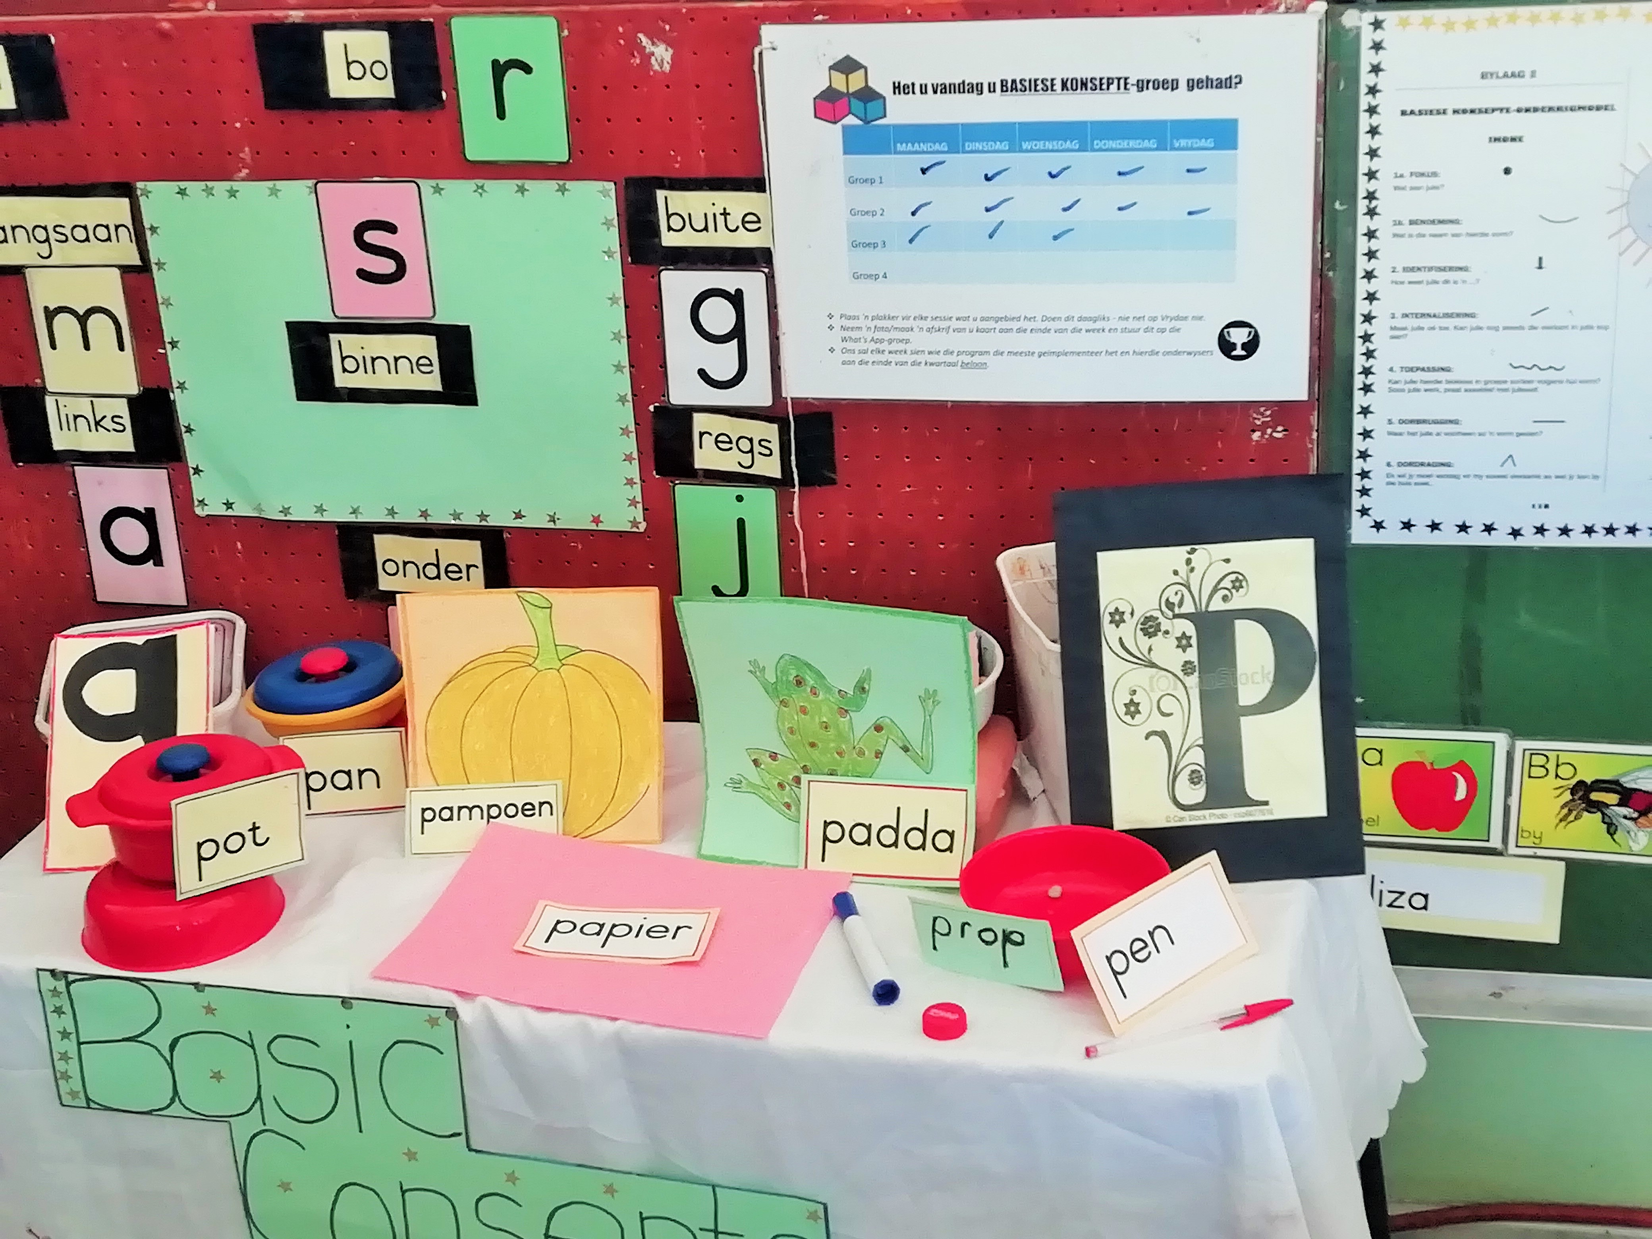
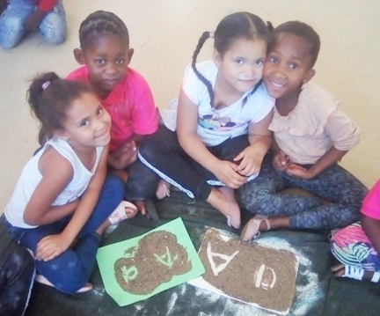

Letter Theme Table and Wall Posters Letter writing using sand on sheets of paper
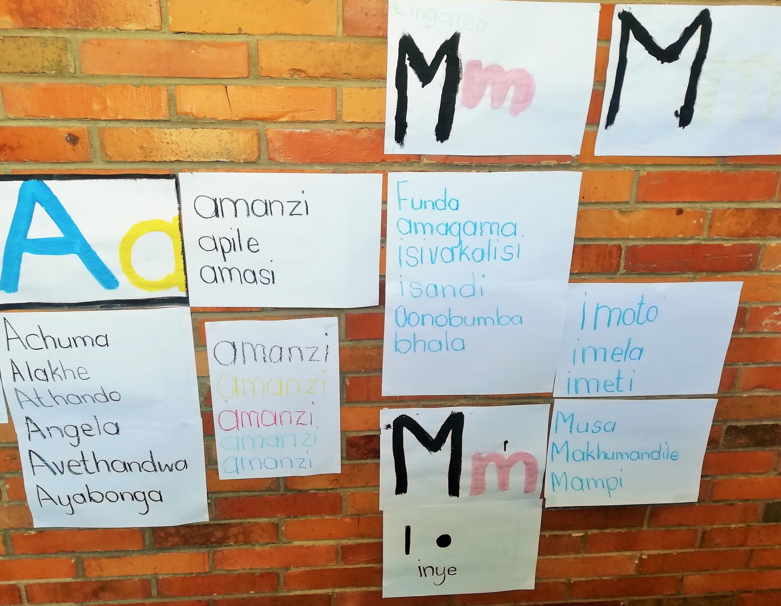
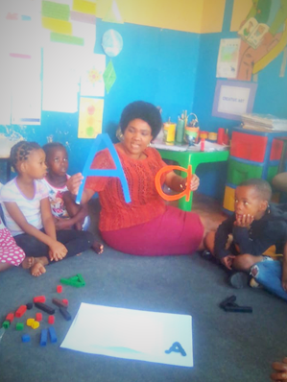

Letter wall posters and learner work Teacher mediating the Letter A.
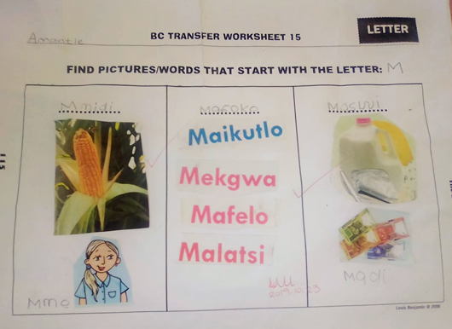
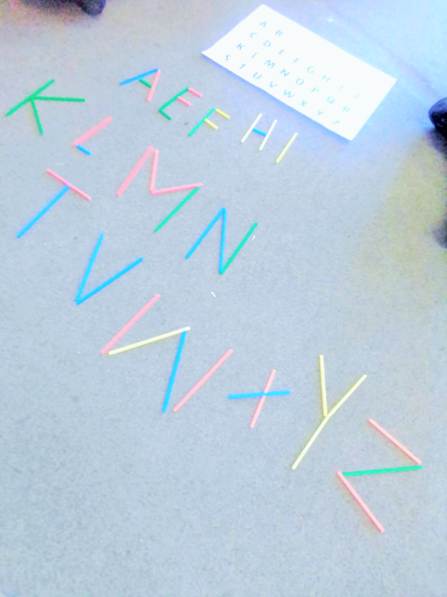

BCs Workbook with a focus on letter. Building/constructing letters
Mediational/teaching environment-

- The main focus of the visit was on the development of mediational teaching. (See Section 1 above and also refer to Visit 3 report.)
- The support teams received further training to identify and support the development of the teachers as mediators. A new ‘Mediational Teaching Observation Sheet’ was introduced during this visit to assist with this task.
- It was found that about 60% of the teachers were moderately to highly mediational, while the rest of the teachers still required assistance to become more mediational.
- While the large majority of teachers have started to ask questions and to follow the steps of the concept teaching model, many teachers still needed to be encouraged to ask individual learners to answer the questions.
- Teachers have almost universally adopted many of the characteristics of a mediational teacher and were mostly comfortable sitting on the mat/chair with their learners in a circle and using concrete materials.
- Although teachers were generally responsive to the guidance during their sessions, many seemed to revert back to old established (non-mediational) teaching practices once the teams left the classrooms and even on occasion during the sessions.

Department of Education: District and Provincial
- The visit again received strong, unequivocal support from the Provincial Department of Education. Two Provincial Officials were part of the visit to JTG, while one of the Provincial Officials was part of the visit to PKS.
- Three other trainee-district officials were part of the visit to JTG, while two other trainee-district officials were part of the visit to PKS.
- The commitment of the district officials responsible for the overall coordination of the project in the current districts was commendable, particularly in the challenging conditions they find themselves.

Volunteers
- Much attention was given to the volunteers during the visit.
- The main emphasis was on assisting them to adopt a more developmental approach in the classrooms with the teachers.
- The volunteers were open to instruction and advice and were willing to try to focus more on the mediation of the teachers during the sessions.
- Some volunteers wanted to know if they had improved during the visit.
- They were motivated and enthusiastic to continue in their role next year.
- A new volunteer in PKS district was interviewed during the visit and has already signed the volunteer contract. An additional volunteer was urgently needed in this district.

Summary and Conclusion
This visit seemed most beneficial for all involved. While the volunteers and officials seemed to benefit from the training and the focus on their role in the classes, the teachers also seemed to respond positively to our visits. The support teams have already had several opportunities to refine their observational skills and interventions in the classrooms during the year. We were concerned that a few teachers seemed not to be implementing as regularly as they should and some (very few) teachers were unprepared for their visits. We did however find that the majority of teachers were making reasonable progress as mediators of the programme. The teachers who were rewarded for their regular implementation of the programme appeared motivated and encouraged by this gesture and so were many of their colleagues.

This visit marked the end of the support visits for the year, however, it also highlighted the need for continued support visits next year. The teachers have almost completed the first year of the project – they have received 6 days of training and have had an opportunity to implement all six conceptual domains with relatively high levels of support. The teachers received on average between 4 to 6 class visits in PKS and JTG respectively. They will be expected to implement the programme independently from the start of the year in 2020, but will continue to receive classroom support during the year. The aim of the final year will be to assist the teachers to establish the programme as a part of their regular and daily classroom routine and to ensure that the programme can be sustained in the future when there might only be limited support available.

The project team has been very impressed with the level of support and involvement of the provincial and district officials. We would like to thank the Northern Cape Department of Education for their unwavering commitment to the project during the first year. We look forward to developing our relationships with the relevant departmental officials so extending our growing operational knowledge about the project in the new year.



APPENDIX 1
Basic Concepts Advocacy Project: Phase 1 (2019 – 2020)
Programme for Visit 4:
John Taolo Gaestewe (05-08 Nov) and Pixley Ka Seme (11-14 Nov)
DATE | Activity | Participants | Time | Comments/Notes/Aims
05 Nov: JTG  11 Nov: PKS | Training | Volunteers and Provincial and District Officials | 8:30am to 3:30pm | The participants will receive a hands-on training to hone their skills as mentors of the programme. They will also receive a brief review of the domains of letter and number.
6- 8 Nov: JTG  12-14 Nov: PKS | School Visits | Support Team to visit teachers | 8am to the end of school day | 30-40 minutes per class visit. The focus of the visits could be on Letter or Number. The visits will give the project team an opportunity to observe the role of the officials and volunteers inside the classroom.
6- 8 Nov: JTG  12-14 Nov: PKS | Visit feedback | Officials, Volunteers and Project Team | 2pm – 4pm | All class visitors bring their completed observation sheets with them to the feedback meeting to give feedback on their visits. Each person on the visit team takes responsibility for reporting back on at least one visit. Discussions follow about the progress of each educator and the interventions that might be required at each school/class.
07 Nov: JTG 13 Nov: PKS | Meeting with District Officials | Project Team and District | 4pm- 4:30pm | To discuss planning for the way forward: Programme for 2020, visits dates, research and data gathering, etc.
07 Nov: JTG  13 Nov: PKS | Meeting with Volunteers | Volunteers, District Officials and Project Team | 4:30pm- 5pm | To get feedback from volunteers and to plan the next set of visits to the teachers. Attempt to clarify and sort out any problems or make a note of these issues.

