Northern Cape Basic Concepts Advocacy Project – Phase (2019-2020)

Exploratory Visit to Two Districts, 6-9 November 2018

Purpose of the visit:
The visit was arranged to the Pixley Kaseme (PK) and John Taolo Gaetsewe (JTG) districts, the two districts where the project will be initiated next year. The project leader, accompanied by three provincial officials from the NCDOE, visited the districts to do preparatory as well as advocacy work ahead of the start of the project.
The main objectives of the visit were to:-
- Meet with the district leadership and local officials
- Plan the project logistics with local officials
- Meet with selected schools and project participants
- Determine the overall on-site logistics and travel requirements for the project team
(See Appendix 1 for the visit agenda given to the districts in preparation for the visit.)

General impressions and outcomes:
The visit to both of the districts was highly successful. Much was achieved in terms of planning and advocacy, but more importantly we were pleased with the level of interest and motivation of the local district officials. It should also be noted that the provincial officials who accompanied the project leader were exceptional in terms of their support and knowledge of the programme in their engagements with the districts.
The district leadership seemed generally supportive of the project – both district directors placed emphasis on the importance of improving the education system from bottom up instead of trying to ‘fix it’ at the top during the last year of schooling.
The advocacy sessions were handled differently in the two districts. In the PK district the session involved over 40 participants (teachers, principals and HODs) from the selected schools, while in the JTG district there was a smaller group of participants (15) representing three of the selected schools. In JTG district we were also able to do a school visit to one of the schools that attended the advocacy session.
The districts are close to finalizing their lists of participants for the project. It was most helpful to meet with the district officials to discuss the many complexities associated with the location of schools and visitations that they will receive. In the Northern Cape distances are vast and the schools are far spread. In addition, it has been recommended by the NCDOE that the teachers selected for the project have completed their studies – so as not to detract from the project or from their studies. Approximately 45 teachers per district have been identified, however, when one includes the volunteers, officials and project team members there will be around 60 people involved with the project per district.
One of the districts has already identified a venue for training, while the other is in the process of selecting a venue. The districts still need to recruit suitable volunteers – but progress was made in terms of selecting these volunteers. The research and evaluation of the project to be conducted by Alacrity Development was broadly discussed during the sessions with the district officials.
While the visits to the districts were relatively short in duration, it seemed that the officials were already at a relatively advanced stage of planning. The visit did however assist to refine their planning and to focus on components of the projects that had not yet been addressed.

Summary of activities:
Pixley Kaseme (6-7 November)
Nature of Activity | With Whom | Place | Numbers
Advocacy Meeting | Teachers and school representatives | Colesberg, Lowryville Primary | 40
Meeting | District Director | De Aar, District Office | 7
Information Session | District Officials | De Aar, District Office | 14
Meeting | Head of Grade R | De Aar, District Office | 5

The visit to the PK district was most encouraging, particularly the initiative taken to invite so many teachers and schools to the advocacy meeting. The advocacy meeting elicited much interest from teachers and the school representatives who attended. The overall response to the project by the district was very positive, however the interest and commitment of the responsible official (Head of Grade R) was particularly reassuring. There is still some work to be done before the start of the project in this district, but all indications are that the official responsible will be well equipped to manage these tasks.

John Taolo Gaetsewe (8-9 November)
Nature of Activity | With Whom | Place | Numbers
Meeting | District Director | District Office, Kuruman | 9
Advocacy Meeting | Teachers and school representatives | Science Centre, Kuruman | 18
Meeting | Heads of Grade R | District Office, Kuruman | 4
School Visit | Grade R teachers and Principal, Moraladi Primary School | Kuruman | 7
Venue for training: check | Local district officials | Kuruman | 4
Meeting | Heads of Grade R | Wimpy, Kuruman | 4

The district was also very welcoming and interested and has given us their commitment to the project. The three local officials (Heads of Grade R) were very supportive and involved in the planning and discussions around the implementation of the project. It was particularly insightful to see Grade R classes (x2) that will be involved in the project. The environment inside these classes was not only impressive in terms of their neatness, organization and resources, but also the openness of the educators to welcome us into their space. While much was achieved during this visit, there is still some work to be done to prepare for the start of the project. A list of six main follow up tasks were identified during this visit.

General logistics for the project team:
There were a number of points that I became aware of during my trip that should assist with the advanced planning for the project. The distances between schools, particularly in the PK district, are vast. We are still in discussion around the final list of schools in both districts – we have recommended that certain schools be replaced by other more accessible schools. The training teams will need to drive approximately 3 hours to reach their base station for the project; that is either in De Aar or in Kuruman. However, during mentoring and support visits to PK it is recommended that the teams base themselves in other, smaller towns. Although I was not able to travel to many of the areas that will be involved in the project, it does seem that most areas are connected by a reasonably good road infrastructure and communication system. It will be possible for the project team to arrive at their base station Sunday and to leave for home on a Friday.

Conclusion:
The exploratory visit was most helpful for the future planning of the project, but also in terms of building the professional partnerships that will be needed during the implementation phase of the project. The trip was also helpful in terms of the advocacy component of the project and preparing the districts for the launch of the project next year. The ability to view the actual environment provides enormous contextual insights that will be of great assistance in the future. The most encouraging aspect to the trip, however, was related to the positive engagements between all role players (provincial, local/district and project team) and their uniform support of the project.

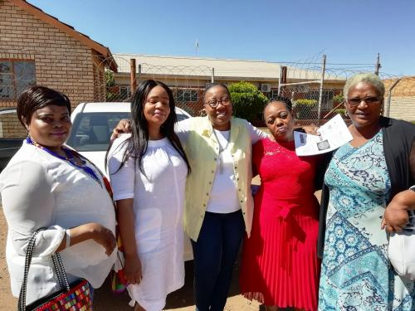
Provincial and District Officials from the JTG District, Northern Cape

