

NAMAQUA EDUCATION DISTRICT (2016-2017)
A Basic Concepts Project for Grade R Practitioners and NCDOE Officials

Field Visit 7:
Information Session for Officials
(16 October 2017)

Mentoring of Teachers & Training Officials to Mentor
(17-18 + 20 August 2017)

Graduation Ceremony
(19 0ctober 2017)

Aim of Project

The project aims to significantly improve the quality of teaching-learning in Grade R classes in selected clusters of the Namaqua District. The project is premised on the assumption that improved teaching and learning in Grade R will contribute towards improved learning in the Foundation Phase and particularly in Grade 1. The project focuses strongly on the development of Grade R teachers as mediators of learning experiences in order to develop learners’ language and conceptual understanding. District Officials have been trained to coach and mentor these teachers in their classes. The project also includes a team of officials from the Northern Cape Department of Education (NCDOE) who are being trained (Phase 1) to extend the project to all Grade R teachers in the province.

Information Session for Officials:

- 10 officials representing 4 districts and the head office in Kimberley attended the information session on the first day of the visit. One of the officials from head office was not able to attend.
- The main purpose of this final information session was to review and consolidate understandings about the programme as well as to give the three officials who had not yet presented, an opportunity to do so.
- The officials who had presented in the previous information sessions were given an opportunity to briefly share (5 minutes) their main understandings about the programme with their colleagues and were encouraged to ask each other questions.
- These mini presentations reflected a depth of understanding about the programme as well as the process needed to implement it in the district.
- The officials spoke convincingly about several of the main components of the programme as well as the linkages to the primary and secondary outcomes of the approach (Appendix 2). It was however the examples given by the officials that offered the most insight into their understanding of the approach.
- Several officials indicated that they had become aware that learners who were struggling often had underlying language deficits and conceptual difficulties.
- The officials were uniformly supportive of the approach and its perceived benefits for children and their learning as they progress through the education system. For example, many officials praised the importance of the programme for developing critical and flexible thinking which they felt were missing in the general education system.
- The officials commented that they had new respect for the teachers of the Namaqua District after seeing them work with their learners. This was their fourth visit to the project all of which have included teacher mentoring sessions inside the classes.
Mentoring of Teachers & Training Officials to Mentor:

Visit Statistics
- Number of teacher contact sessions including teacher observations and feedback sessions with teachers: 22 out of the total of 27 teachers were seen. (Two teachers were ill, two teachers at one school could not be observed because of time constraints, while one school could not be reached.)
- Number of contacts with schools: 16 out of a total of 17 schools
- Number of local district officials involved in the visit: 2 out of 4 officials

Visit Overview
- Provincial officials were divided into four teams, three of which were accompanied by a more experienced local district official or myself. The teams did their visits on 17 and 18 October, while I was able to visit an additional teacher on my way home on 20 October.
- A total of 22 teachers from 16 schools were visited. Only five teachers from 4 schools still need to be visited by the district office.
- It has also been recommended that four teachers who were visited receive additional support by the district team.
- The officials met after their visits to give detailed feedback about their observations. This was supported by video and photographic evidence that was gathered during the visits. The officials were required to complete and submit an observation sheet during their visits.
- This was the fourth opportunity the provincial officials had to observe and to give feedback about the teachers. During this visit however they were encouraged to assume a more active and even interventionist role inside the classes. The officials had done some preparation before the class visits to plan for possible interventions that might be needed during the sessions.
- The afternoon feedback sessions with the officials consisted mainly of discussions about the teachers’ strategies and recommendations to help them to improve as mediators of the programme.
- It was evident that the officials had started to guide and direct the teachers during the sessions and had made recommendations to help them. While some of the officials decided to only give feedback to their teachers at the end of the sessions, others had started to coach teachers during their sessions.
- The feedback from the officials often seemed to agree closely with my own observations about the teachers in the past as well as the observations of their colleagues – The feedback of the officials thus seemed to accurately capture the progress of the teachers as mediators of the programme.
- The teachers had been requested to run a ‘letter’ demonstration session. At the start of the fourth term they had been asked to switch to the conceptual domains of ‘letter’ and ‘number’. Most teachers ran a ‘letter’ session, but some had not been informed and had prepared a ‘number’ session.
- As the school term had only recently started, the teachers had just begun to mediate ‘letter’. It was however expected that the learners would have some background knowledge about the domain from the curriculum and it was also thought that they would now be better able to apply their understandings from previous domains to assist them to learn about letter.

Observations of Mediation
- The majority of the teachers had only recently begun to mediate ‘letter’.
- There were however a number of teachers (8) that had already made much progress with the mediation of ‘letter’. Many of the children in these classes could already read and write.
- There were concerns that some teachers (5) had not yet started to mediate ‘letter’ or had only begun because of the visits to their classes. It was possible that some of these teachers had not understood that they now had to work with two conceptual domains (namely ‘number’ and ‘letter’) at the same time, as they had mostly been working with ‘number’.
- The feedback about the quality of the mediation in most of the classes was very positive and this even included some of the teachers who had not yet started to mediate ‘letter’.
- It would seem that the teachers’ past experience of mediating the programme had helped them to apply it to the new domains. It is interesting that the seemingly more challenging domains of ‘letter’ and ‘number’ could be mediated with greater ease than the less complex domains of colour and shape.

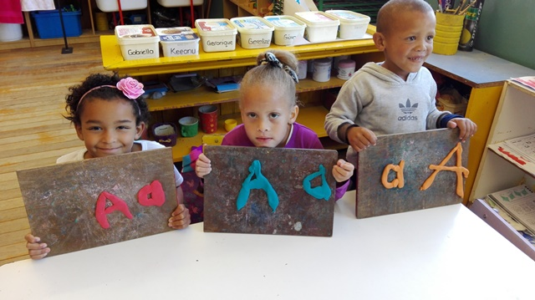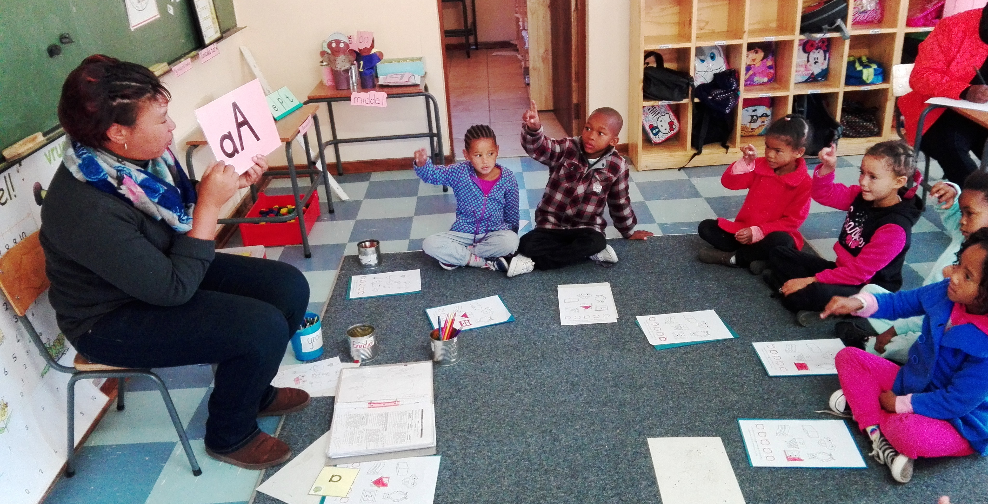

- The physical environment in the majority of the classes reflected the new conceptual domains, however some classes had not yet started with ‘letter’ or it was evident that the ‘letter’ environment could be further enhanced. Many classes did not yet have theme tables for ‘letter’.
- The learner workbooks in many classes did not yet have ‘letter’ work in them, however, we did find number work in the workbooks.
- There were a few teachers (4) that have posed challenges. These teachers have received intensive help during our visits and some have even received additional visits by district officials, but they have still not fully responded to this help. It might be that some of these teachers are not as motivated as the others or have become distracted by other issues. For example, some of the teachers worry that they will be retrenched if their learner numbers drop below a certain threshold, while other teachers are worried about passing their forthcoming exams.

Graduation Ceremony
Statistics
- Number of teachers: 24 teachers out of 27 teachers
- Number of provincial officials: 8 officials out of 9 officials
- Number of officials from the Namaqua District: 6 officials
- Number of school principals: 4 principals

Overview
- 24 teachers and 8 officials received certificates at the event. The teachers and officials who were not able to receive certificates at the event will receive them after the event. One teacher will be asked to show additional evidence of implementation.
- The teachers received certificates for implementing the programme consistently and regularly in their classes under supervision. They are now considered as trained mediators of the programme who may implement the programme independently.
- The officials received two certificates, one for attending the training (48hrs) and the other as a trained coach and mentor of the programme (4 sets of mentoring visits). The officials may now support teachers with the implementation of the programme in their districts.
- The speakers at the event were inspirational and gave valuable background about the project in the Namaqua District. They speakers also spoke with much understanding about the programme. Many speakers, including the provincial officials from head office in Kimberley, spoke positively about the proposed extension of the project in the Northern Cape.
- The event also provided an opportunity for the teachers to demonstrate best practice. A collection of work from all 6 conceptual domains had been gathered from the teachers before the graduation and laid out in the venue.
- It seems that this well organized, celebratory event was enjoyed and highly appreciated by all who attended.
*See programme attached (Appendix 3)

Summary and Conclusion
This was my final visit to the project. It was therefore very satisfying to see that the teachers had made so much progress and that they were so competently able to mediate the conceptual domain of ‘letter’. It was however most pleasing to see the number of learners who had already started to read and write and able to make use of several writing conventions. There were a few teachers who had not yet started to mediate both ‘letter’ and ‘number’, but started during the visit. There were also some teachers (4) who still need moderate to strong levels of support and encouragement.

There was a high and almost universal implementation of the programme, except for one teacher whom we think might have stopped to implement the programme for a period of time during the year. The teachers, therefore all received certificates, except for one teacher who might require additional support. The overwhelming sense from the teachers, captured in a feedback sheet during the visit, about the project was very positive.

‘This programme is the best thing that has ever happened to me. I love to work with my learners and love to see how the learners progress.’

The officials from the Northern Cape Department of Education similarly felt very positive about their participation in the project. Many of these officials expressed a desire to extend the programme to the rest of the province and to their own districts. These officials have developed a good understanding of the programme as well as how to support and coach teachers who are implementing the programme for the first time. The officials will be responsible for monitoring the roll-out of the project in their districts in the future.

The final phase of the project involves the collection of data from a representative sample of project learners (20%) when they are in Grade 1 in 2018. They will be tested at the start and again the end of the year with two different test batteries. The final report for the project will be written once we have gathered the last set of data towards the end of the year in 2018. The aim is to compare the post project data with the baseline data that had been gathered in Grade 1 control schools at the start in 2016.

Appendix 1

BASIC CONCEPTS PROGRAMME FOR VISIT 7

16 – 20 OCTOBER 2017

MONDAY  16 OCTOBER 2017 | OFFICIALS | TUESDAY  17 OCTOBER 2017 | OFFICIALS | WEDNESDAY  18 OCTOBER 2017 | THURSDAY  19 OCTOBER 2017 | FRIDAY  20 OCTOBER  2017
Meeting with NCDOE officials  Presentations | Dr. Benjamin  Dipz | MATJIESKOOF RC PR  SPRINGBOK PRIMARY  CAROLUSBERG PR  MEETING | Dr. Benjamin  Dipz | KAMIESKROON PR  DORINGROSIE KLEUTERSKOOL | CERTIFICATE CEREMONY  OKIEP COUNTRY LODGE | J.J. LAMBERT  PRIMARY
Meeting with NCDOE officials  Presentations | Roseline  Merle  Joy | CONCORDIA PR  DR IZAK V/ NIEKERK PRIMARY  MEETING | Roseline  Merle  Joy | PELLA RC PR  MEETING | CERTIFICATE CEREMONY  OKIEP COUNTRY LODGE
Meeting with NCDOE officials  Presentations | Shaheeda  Ruth | OKIEP PRIMARY  FERDINAND BRECHER  MEETING | Shaheeda  Ruth  Yvonne | AGGENEYS PR MEETING | CERTIFICATE CEREMONY  OKIEP COUNTRY LODGE
Meeting with NCDOE officials  Presentations | Jane  Mammetjie  Candy  Yvonne | PORT NOLLOTH RC PRIMARY  PORT NOLLOTH PR  JAPSNOETJIES KLEUTERSKOOL | Jane  Mammetjie  Candy | FRANCOIS VISSER PR  MEETING | CERTIFICATE CEREMONY  OKIEP COUNTRY LODGE

Appendix 2

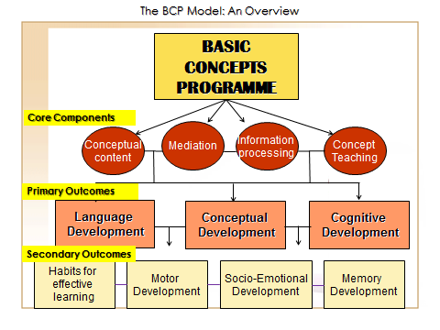

Appendix 3



