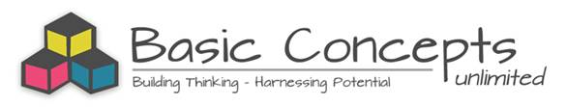
BASIC CONCEPTS VISIT PROGRAM
14 – 18 AUGUST 2017
14 + 15 August: Meeting at Namaqua District with NCDoE officials to review the Basic Concepts Programme. This will include presentations by the officials.
NAAM | WOENSDAG 16TH | DONDERDAG 17TH | VRYDAG 18TH
ZELDA VOLLMER  WITH OFFICIALS OF OTHER DISRTICTS | OKIEP PRIMARY  FERDINAND BRECHER PRIMARY  MEETING | JAPSNOEJIES KLEUTERSKOOL  MEETING
JANE FIELDING  WITH OFFICIALS OF OTHER DISRTICTS | CONCORDIA PRIMARY  DR ISAK VAN NIEKERK PRIMARY  MEETING | PELLA RC PRIMARY  MEETING
MARY CLOETE  WITH OFFICIALS OF OTHER DISRTICTS | MATJIESKOOF RC PRIMARY  SPRINGBOK PRIMARY  CALUSBERG PRIMAY  MEETING | AGGENEYS PRIMARY  MEETING
LOUIS BENJAMIN  WITH OFFICIALS OF OTHER DISRTICTS | PORT NOLLOTH RC PRIMARY  PORT NOLLOTH PRIMARY  MEETING | FRANCOIS VISSER PRIMARY  MEETING | KAMIESKROON PRIMARY  JJ LAMBERT PRIMARY

